Discover Jaipur with INTRO TRAVELS INDIA
Jaipur, the capital city of Rajasthan, is famously known as the “Pink City of India.” Rich in royal heritage, majestic forts, colorful bazaars, grand palaces, traditional culture, and delicious Rajasthani cuisine, Jaipur is one of India’s most popular travel destinations.
Whether you are planning a heritage holiday, honeymoon, family vacation, cultural tour, or luxury getaway, Jaipur offers a magical experience filled with history, architecture, and vibrant traditions.

Why Visit Jaipur?
- Magnificent forts & royal palaces
- Rich Rajput heritage & culture
- Colorful local markets
- Luxury heritage hotels
- Traditional Rajasthani cuisine
- Camel rides & desert experiences
- Perfect destination for photography
- UNESCO World Heritage Sites

Top Tourist Attractions in Jaipur
1. Hawa Mahal
The iconic “Palace of Winds” is Jaipur’s most famous landmark.
Highlights:
- Unique pink sandstone architecture
- 953 windows (jharokhas)
- Royal Rajput design
- Beautiful street views
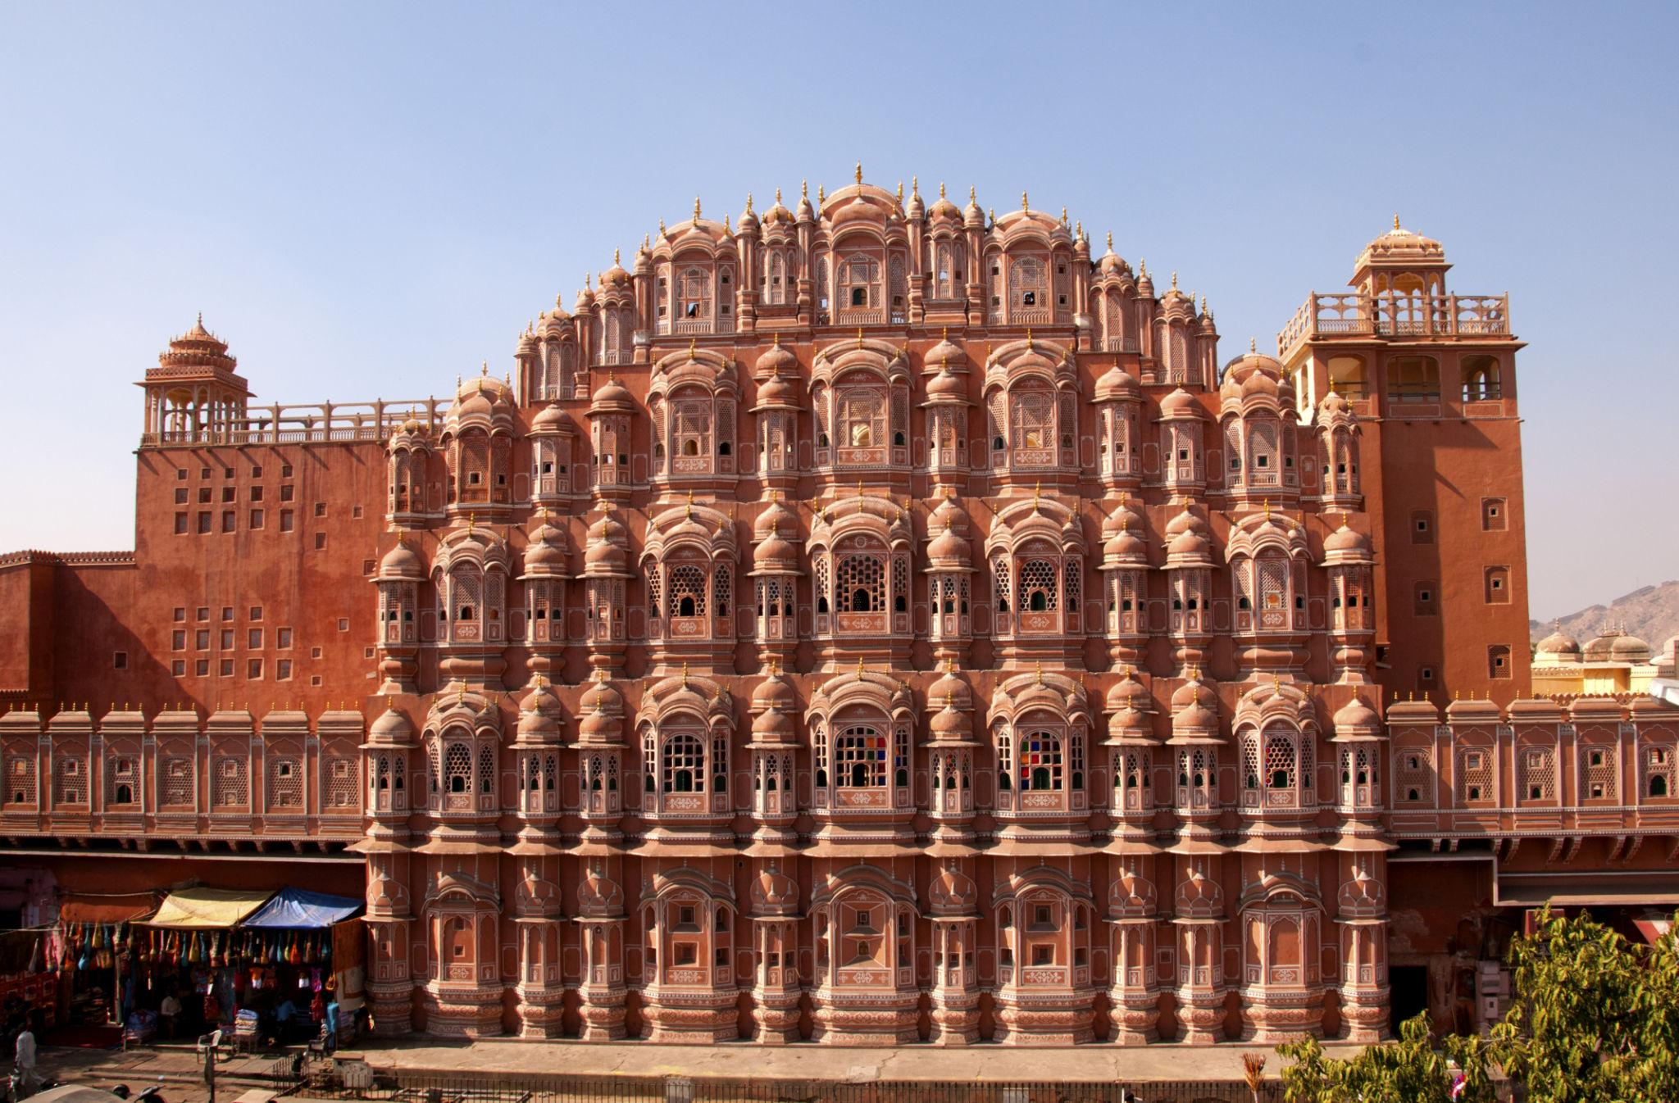
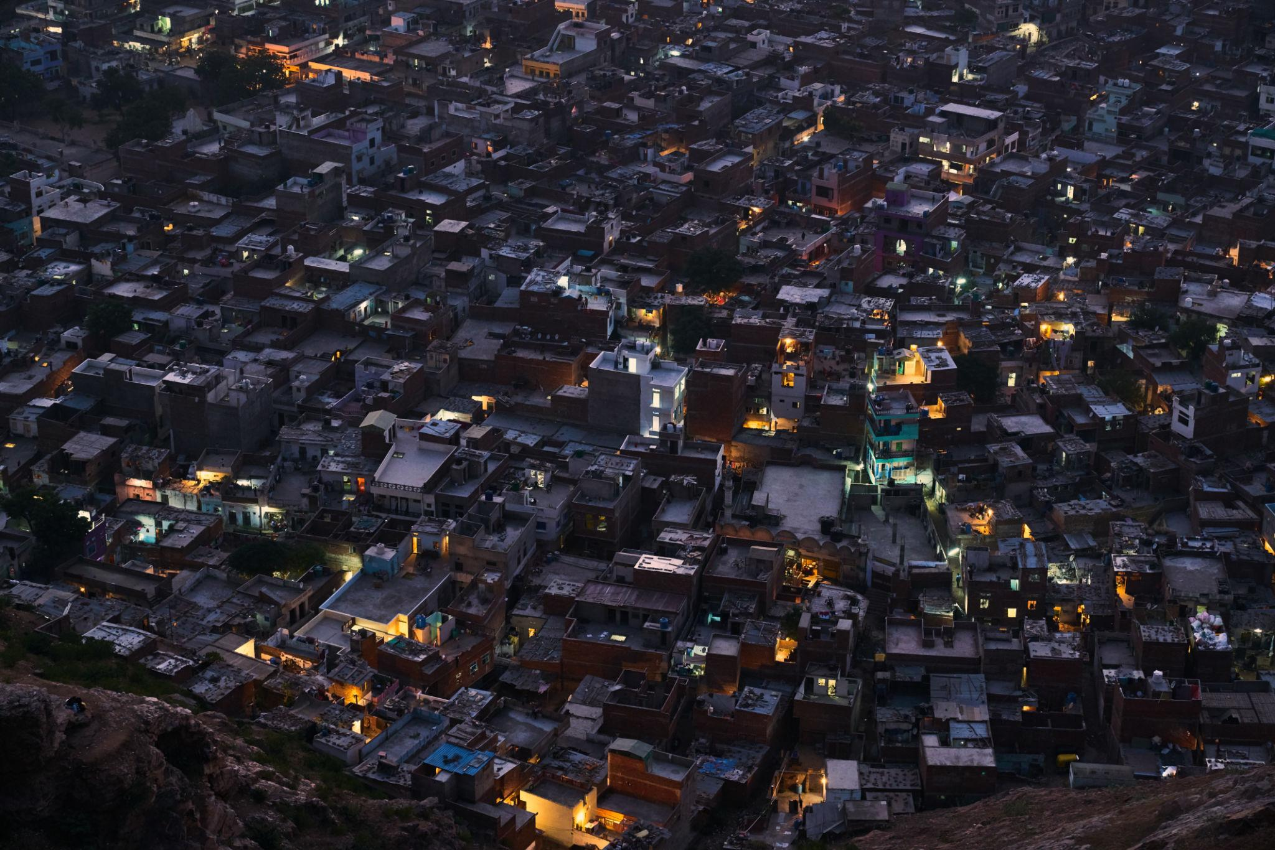
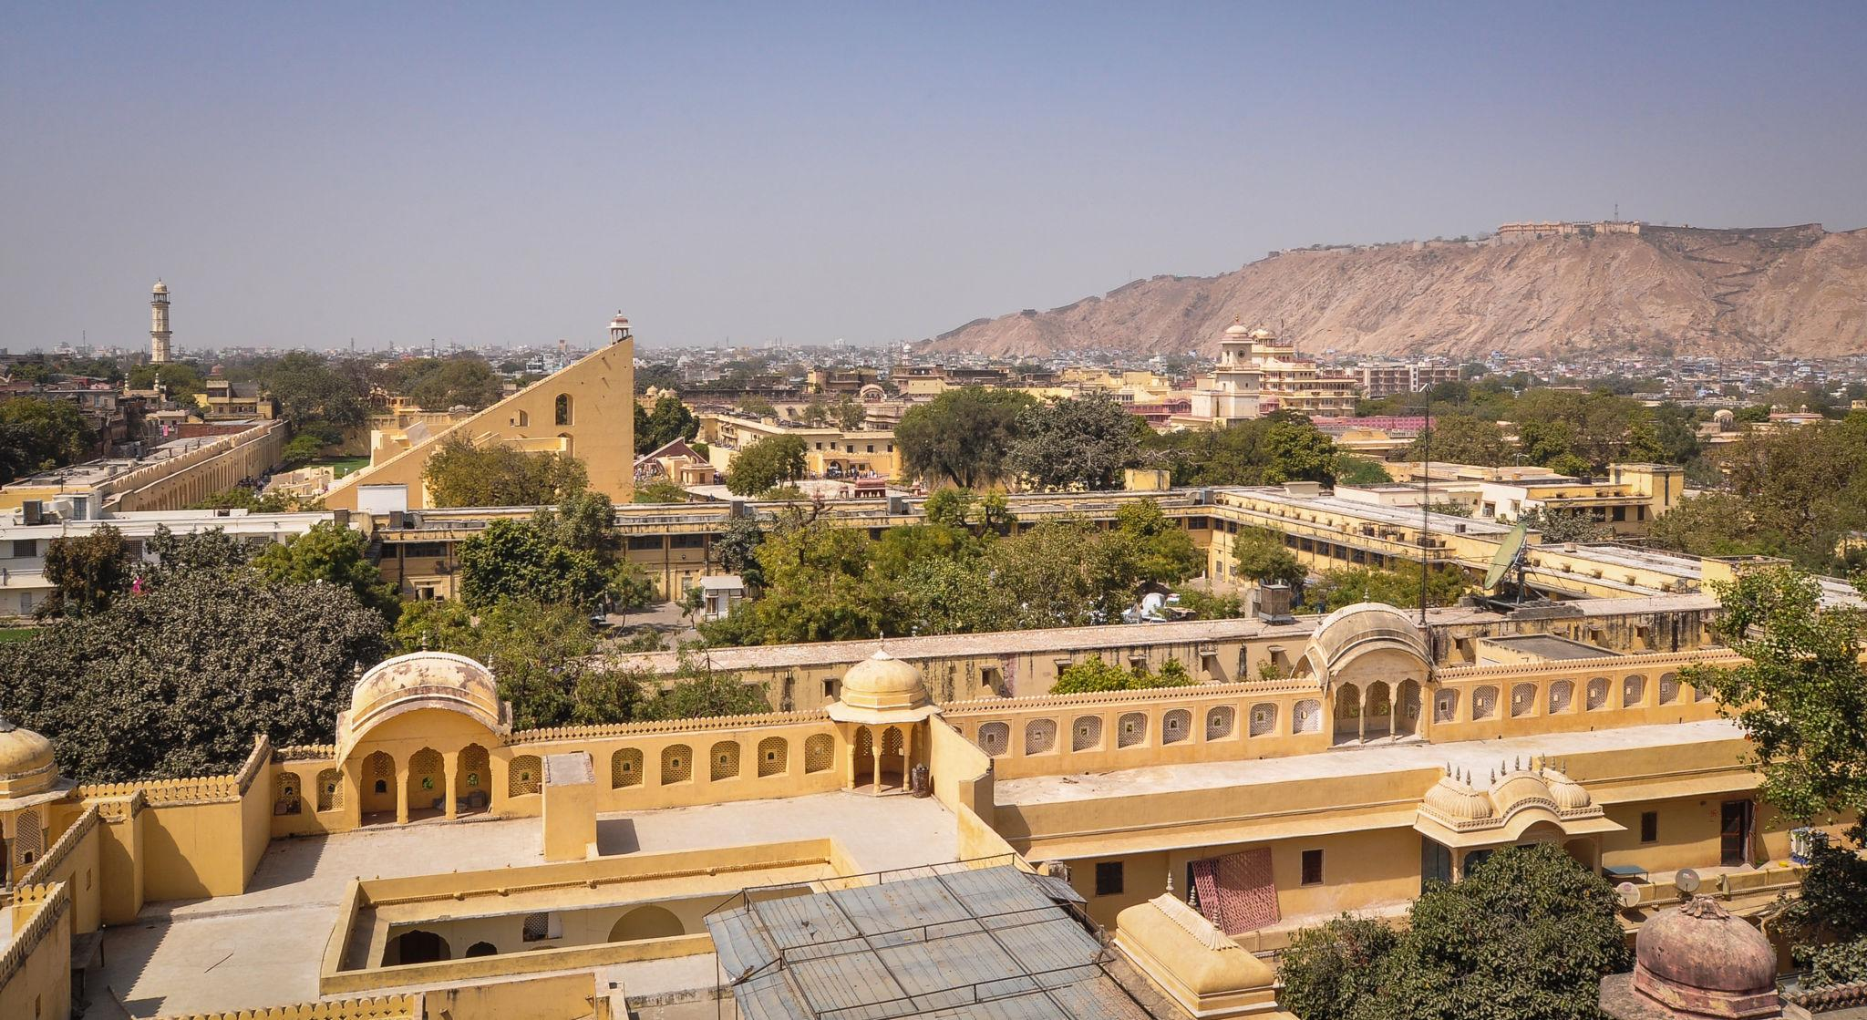
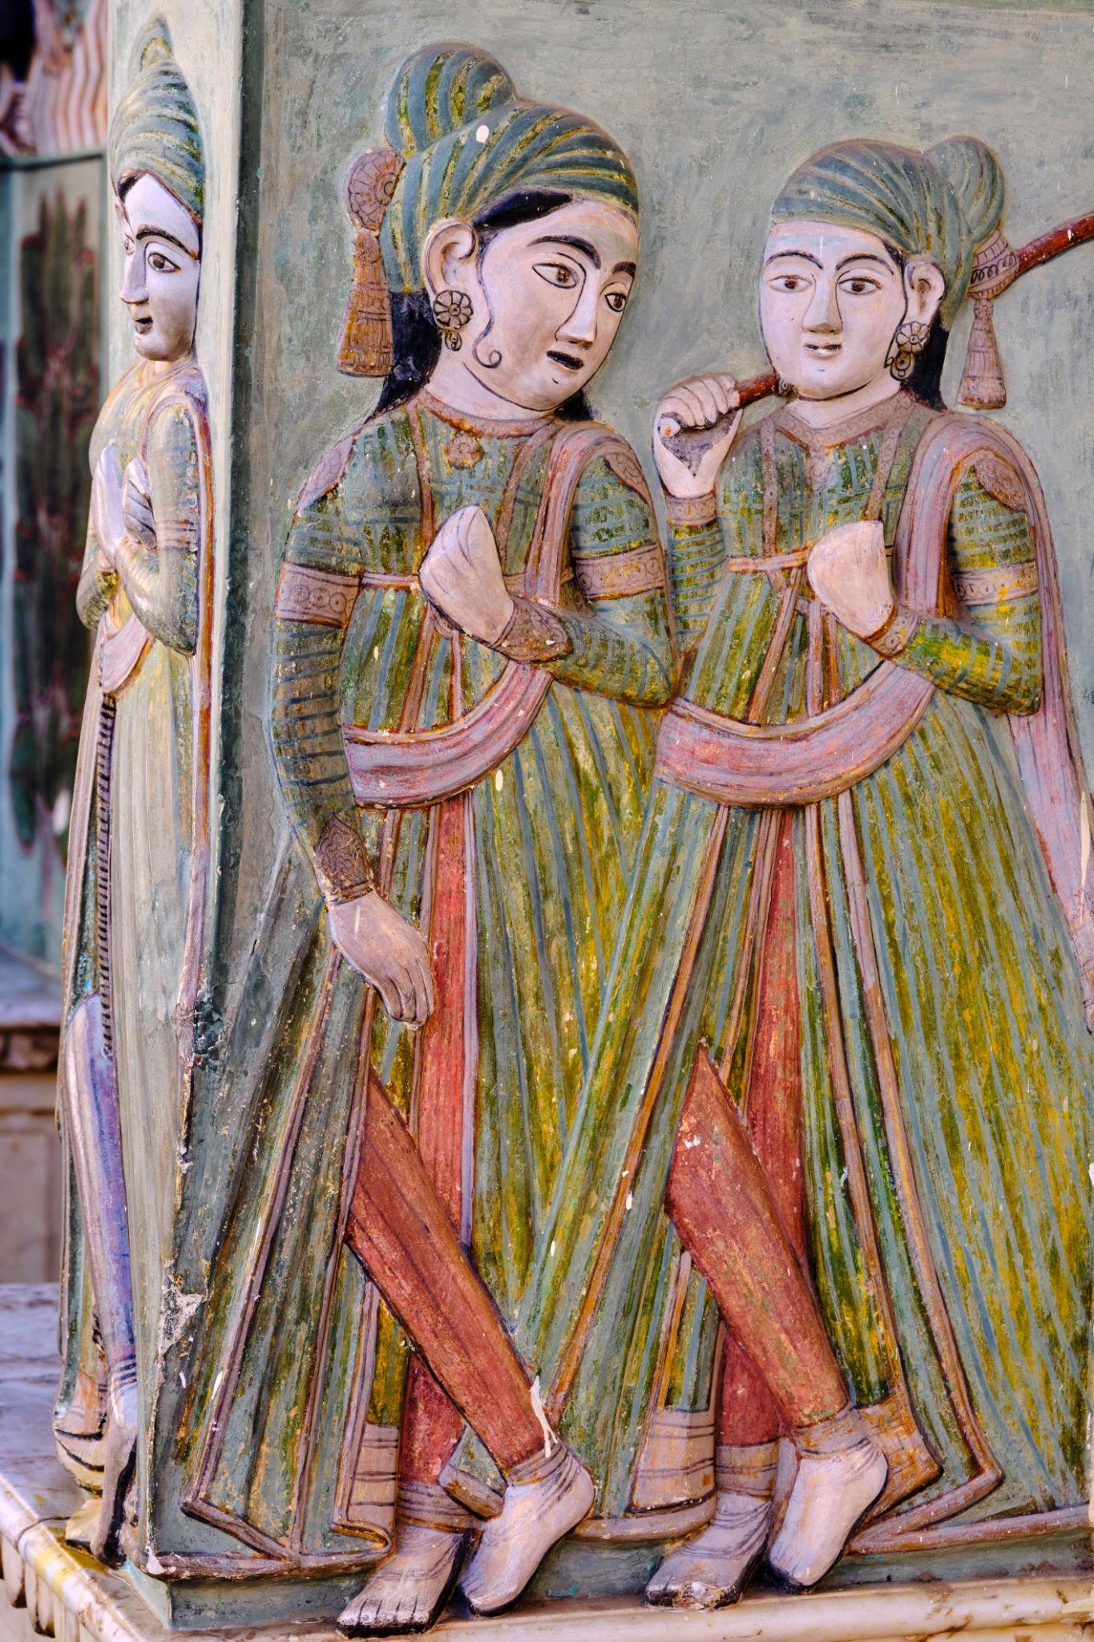
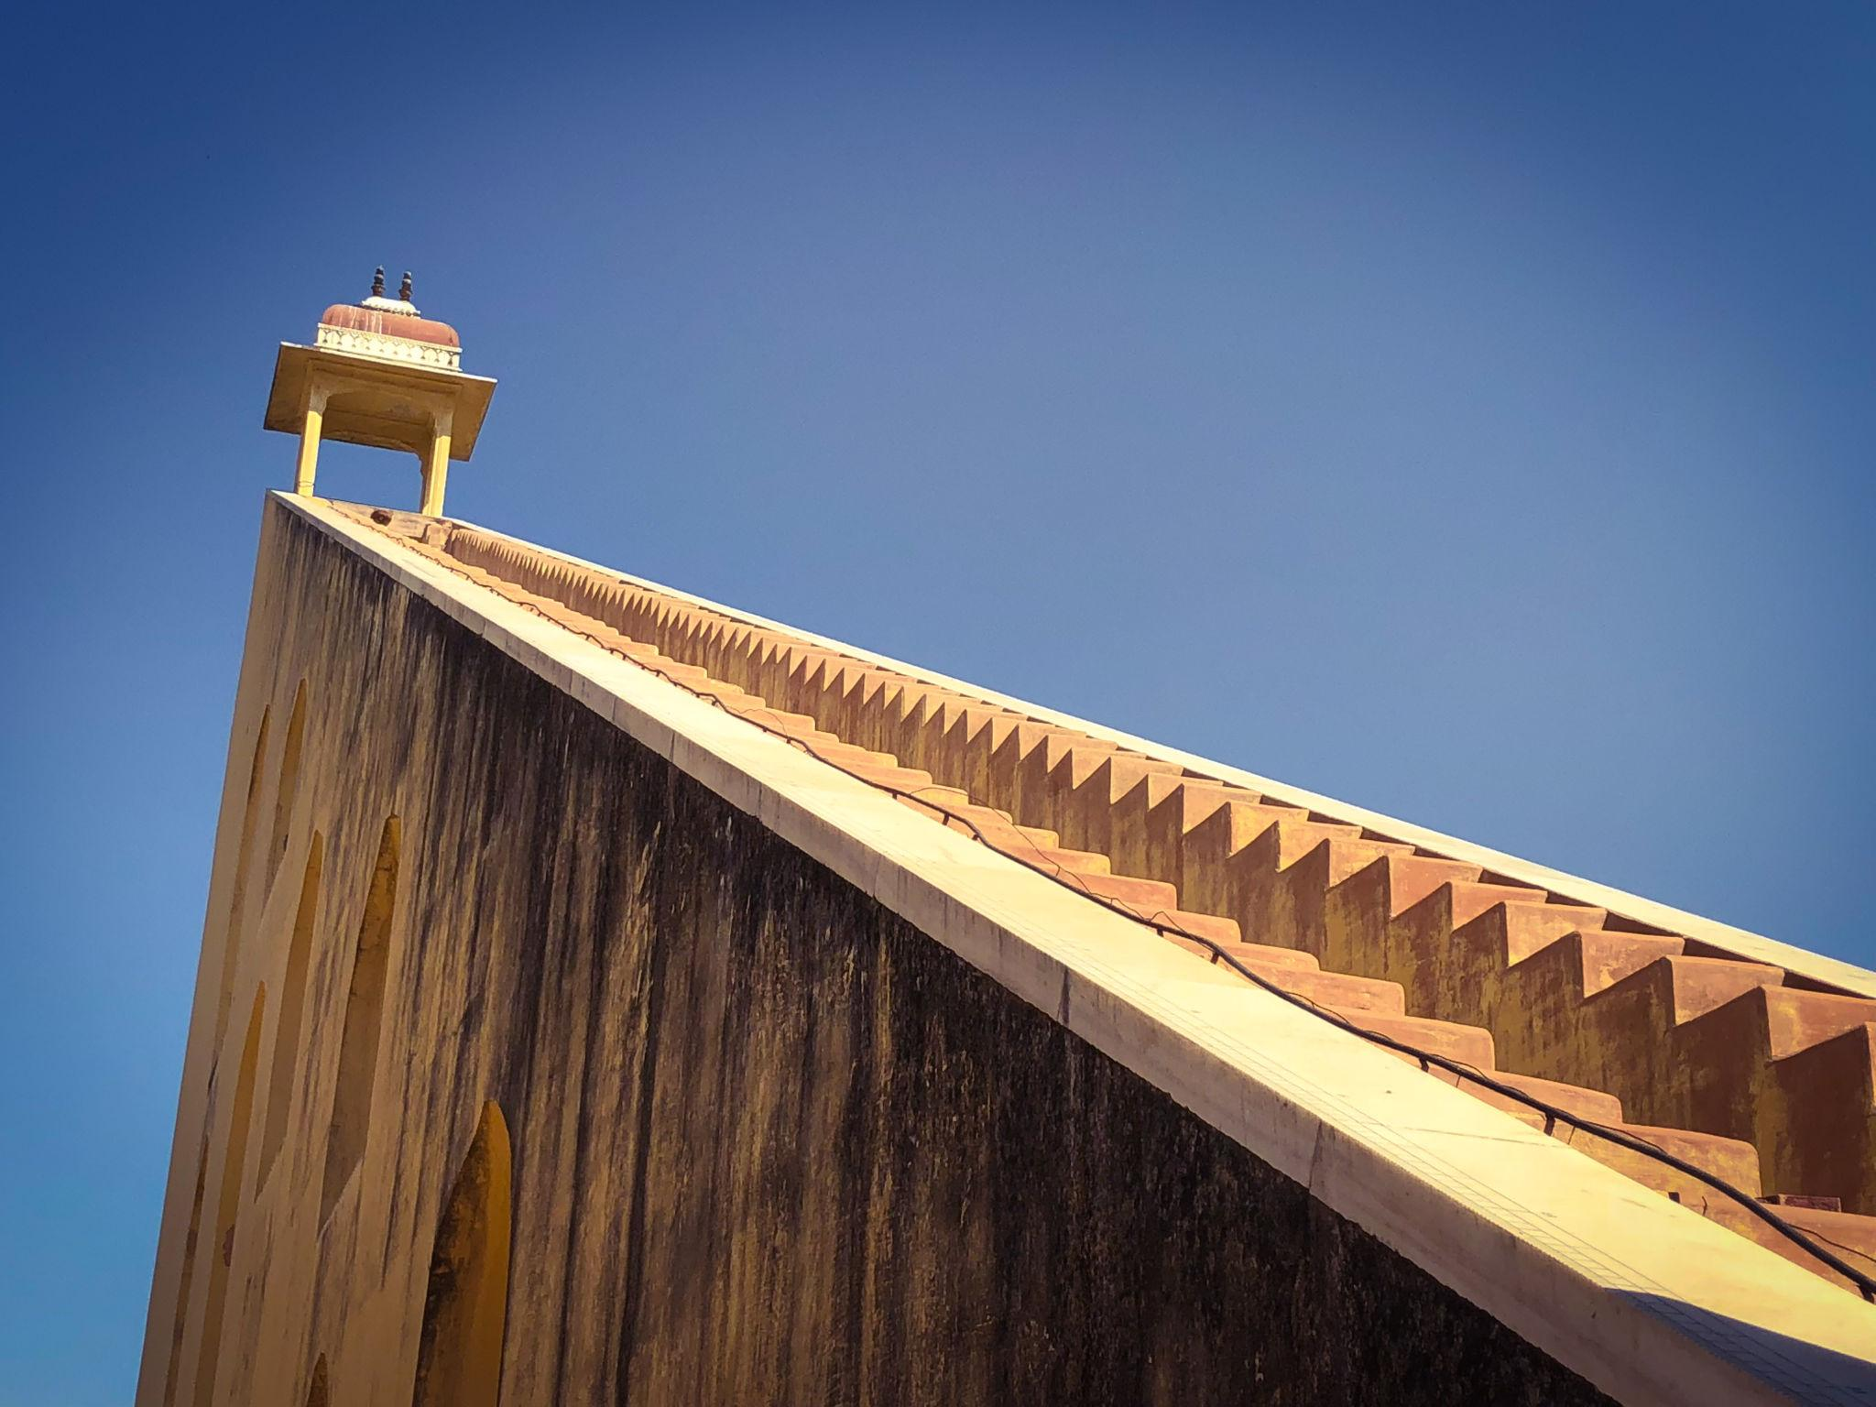
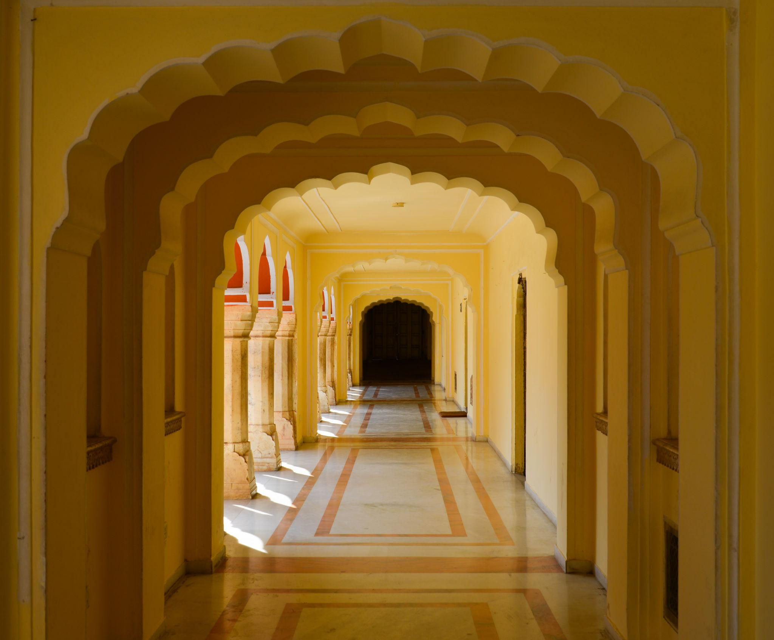
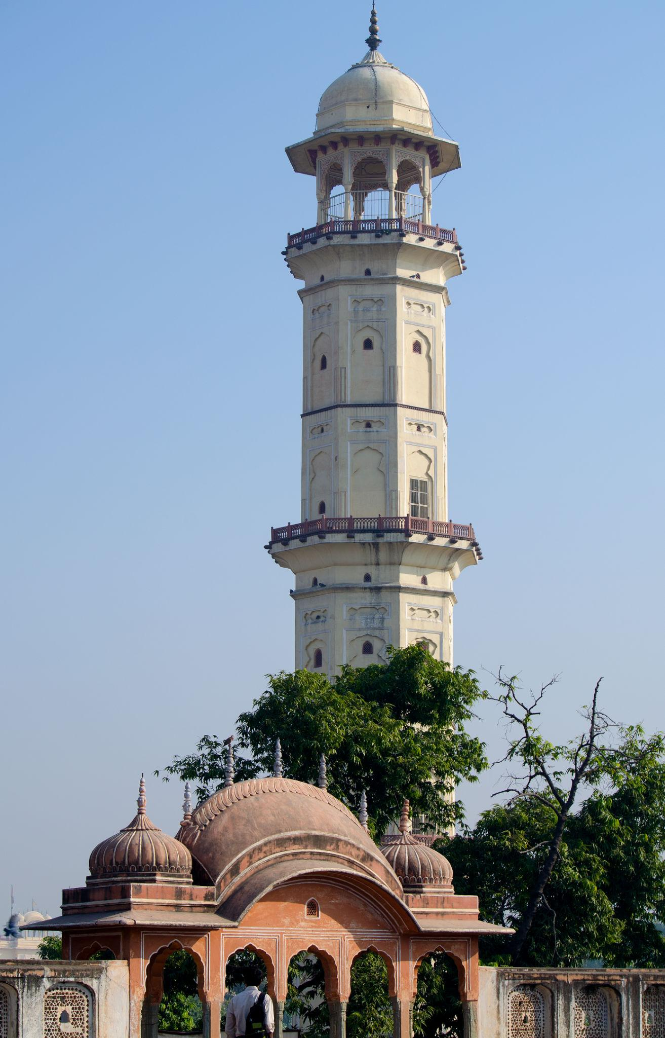

2. Amber Fort
A majestic fort located on a hilltop overlooking Maota Lake.
Known for:
- Royal courtyards & palaces
- Elephant rides
- Sheesh Mahal (Mirror Palace)
- Sound & light shows
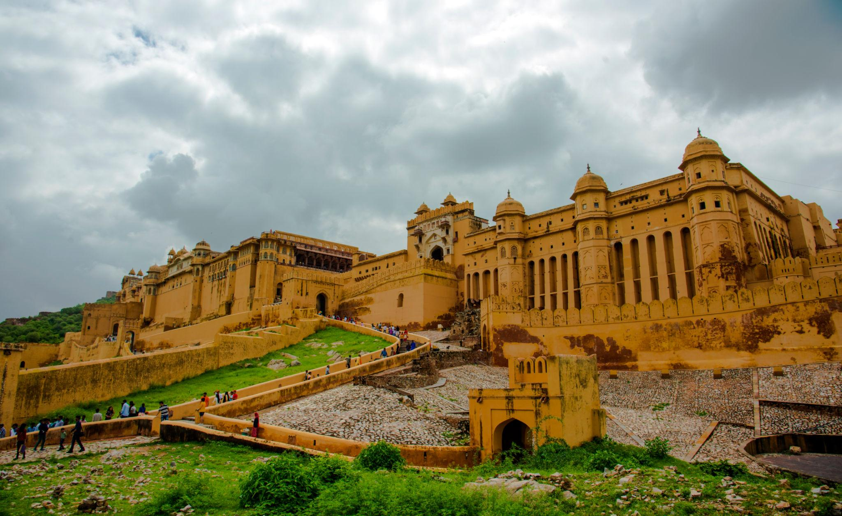
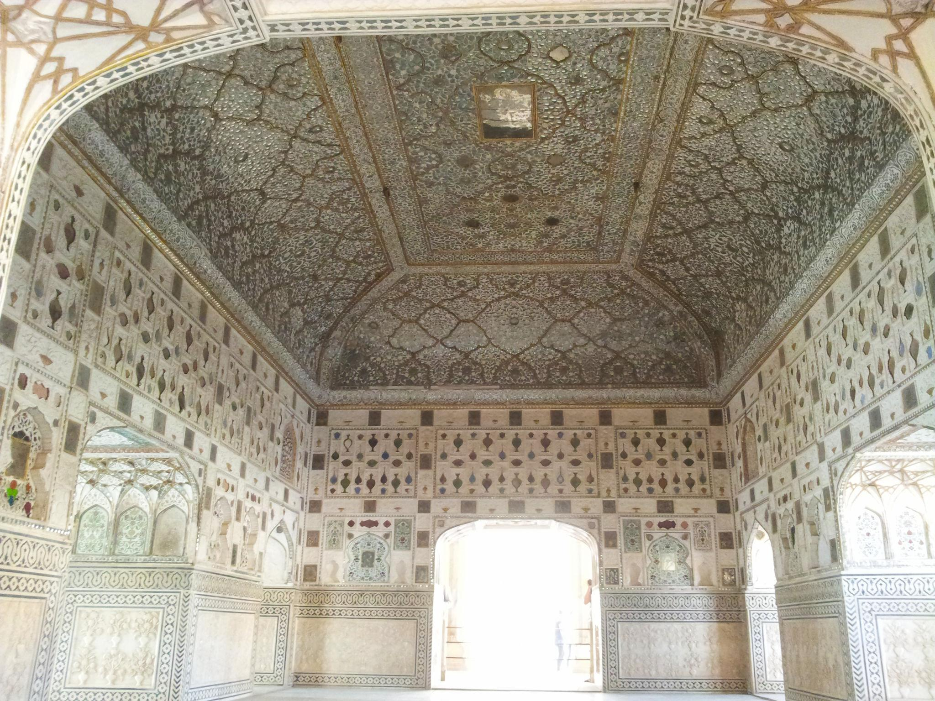
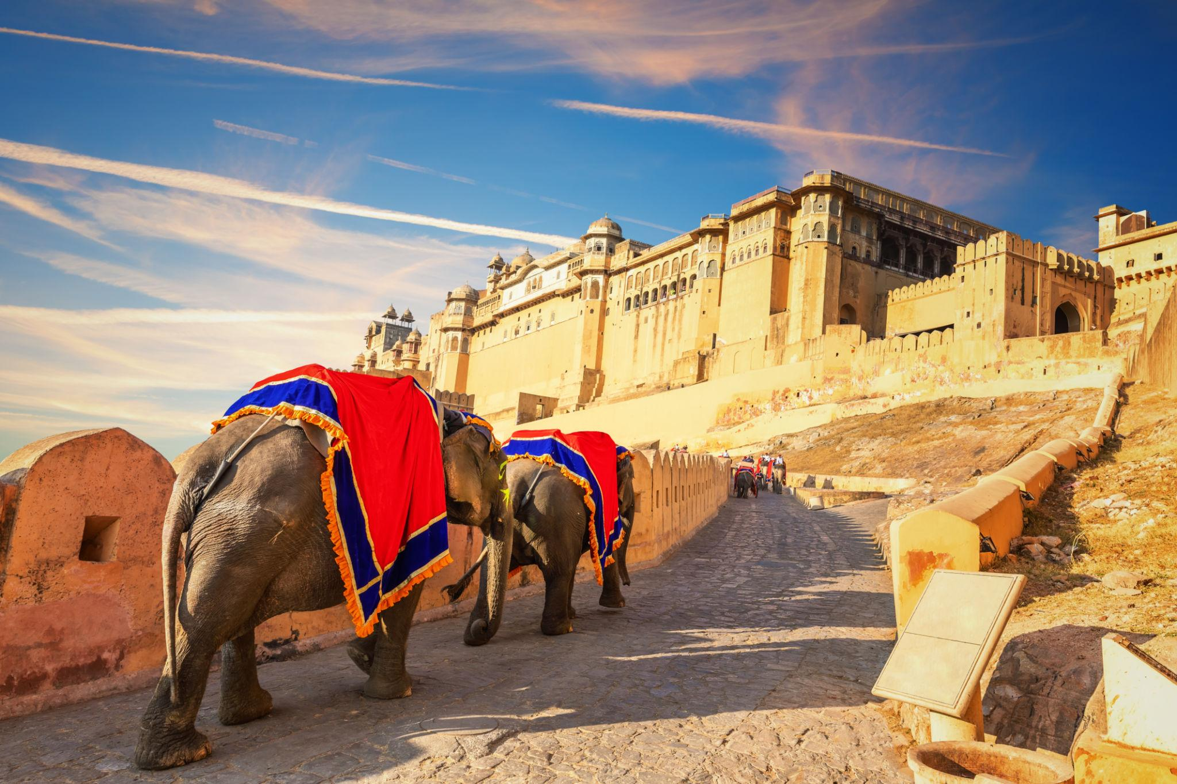
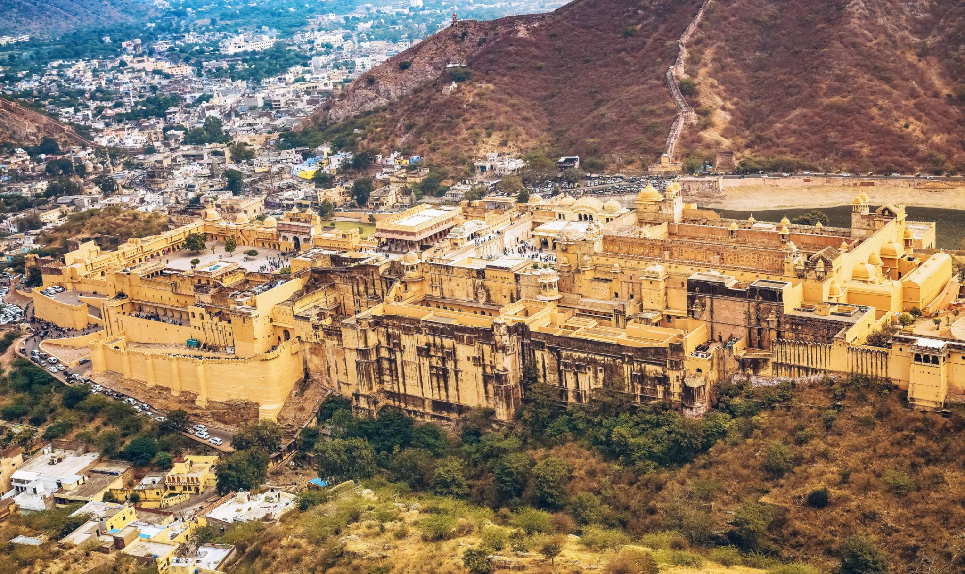
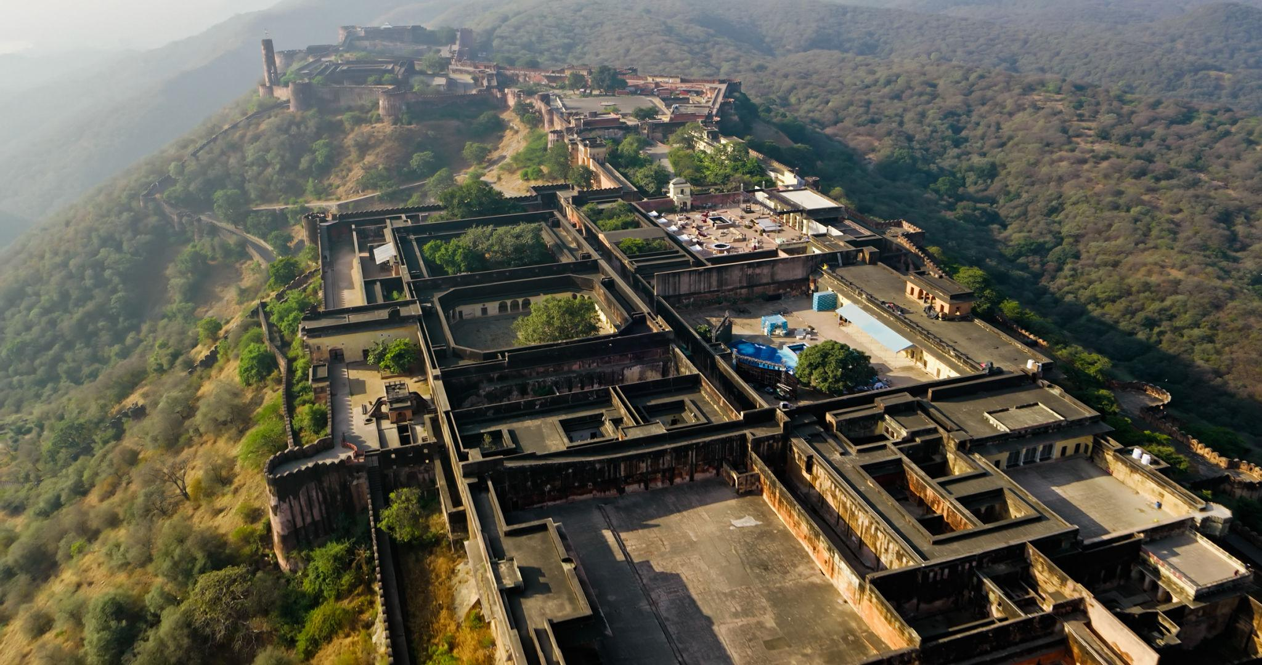

3. City Palace
A beautiful royal palace complex in the heart of Jaipur.
Highlights:
- Museums & royal artifacts
- Traditional courtyards
- Maharaja’s palace
- Royal costumes & weapons
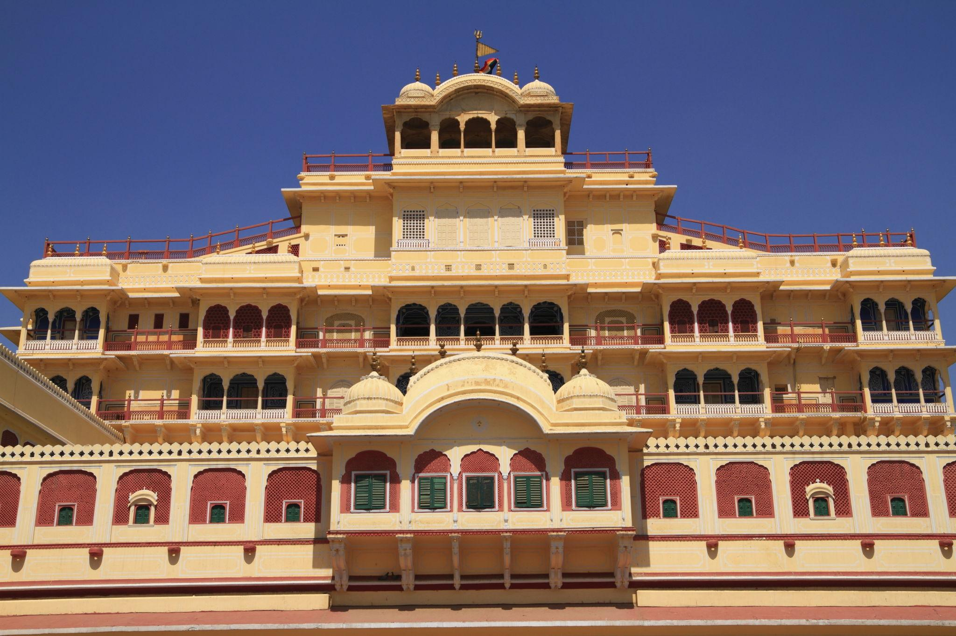
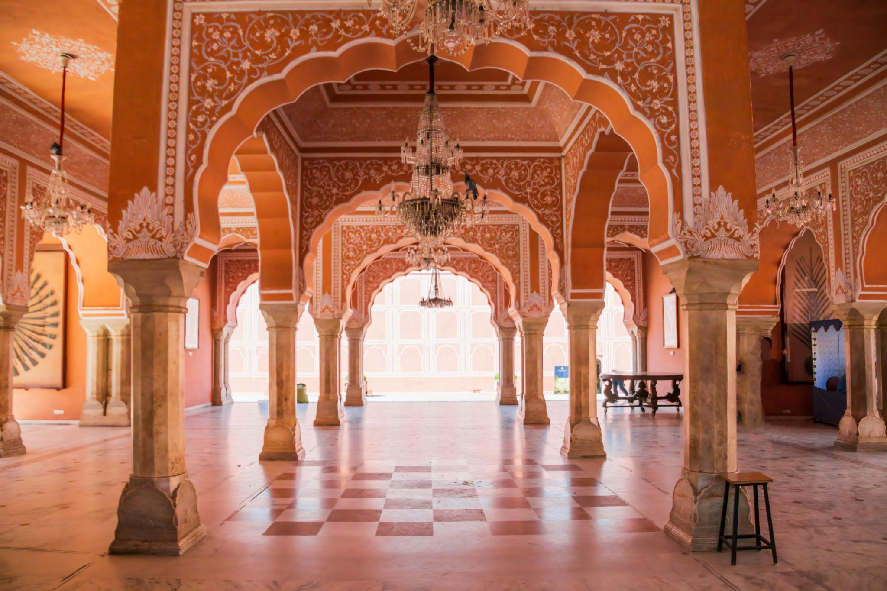
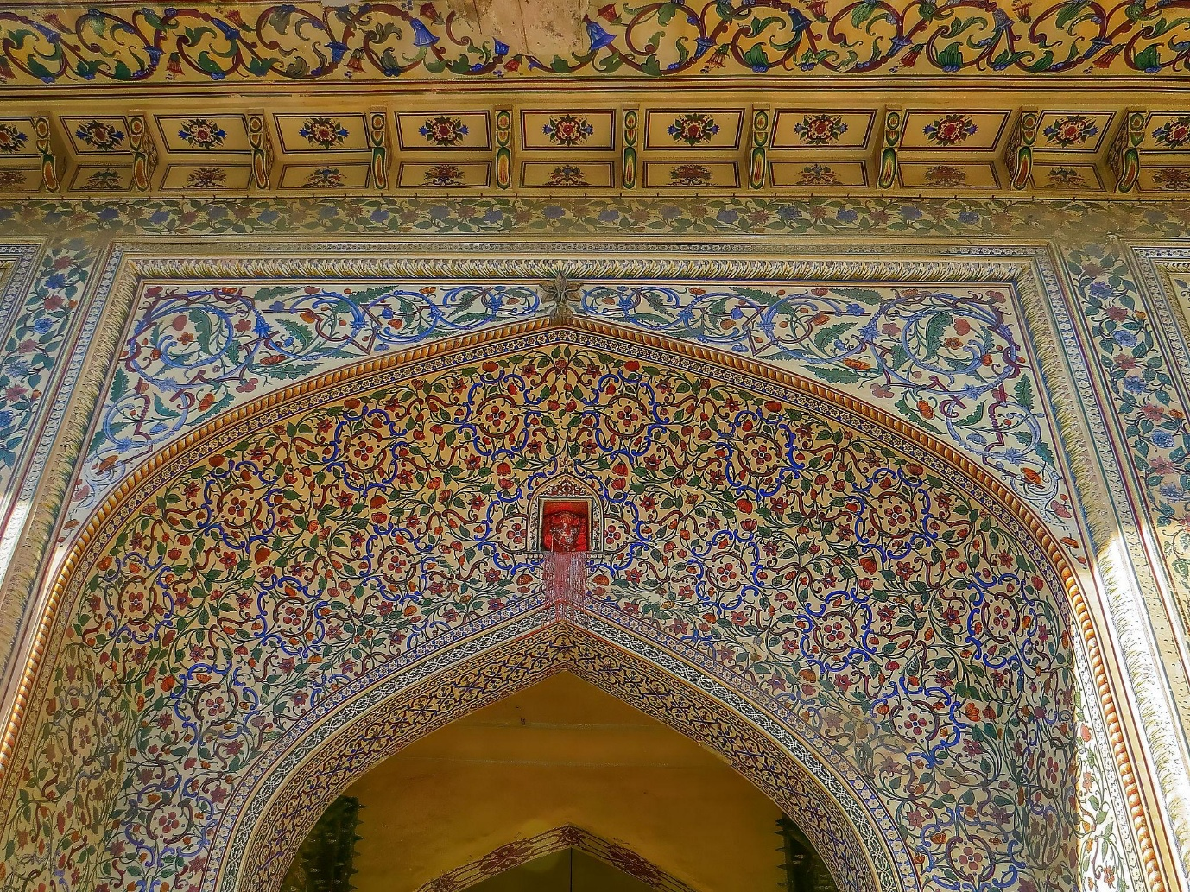
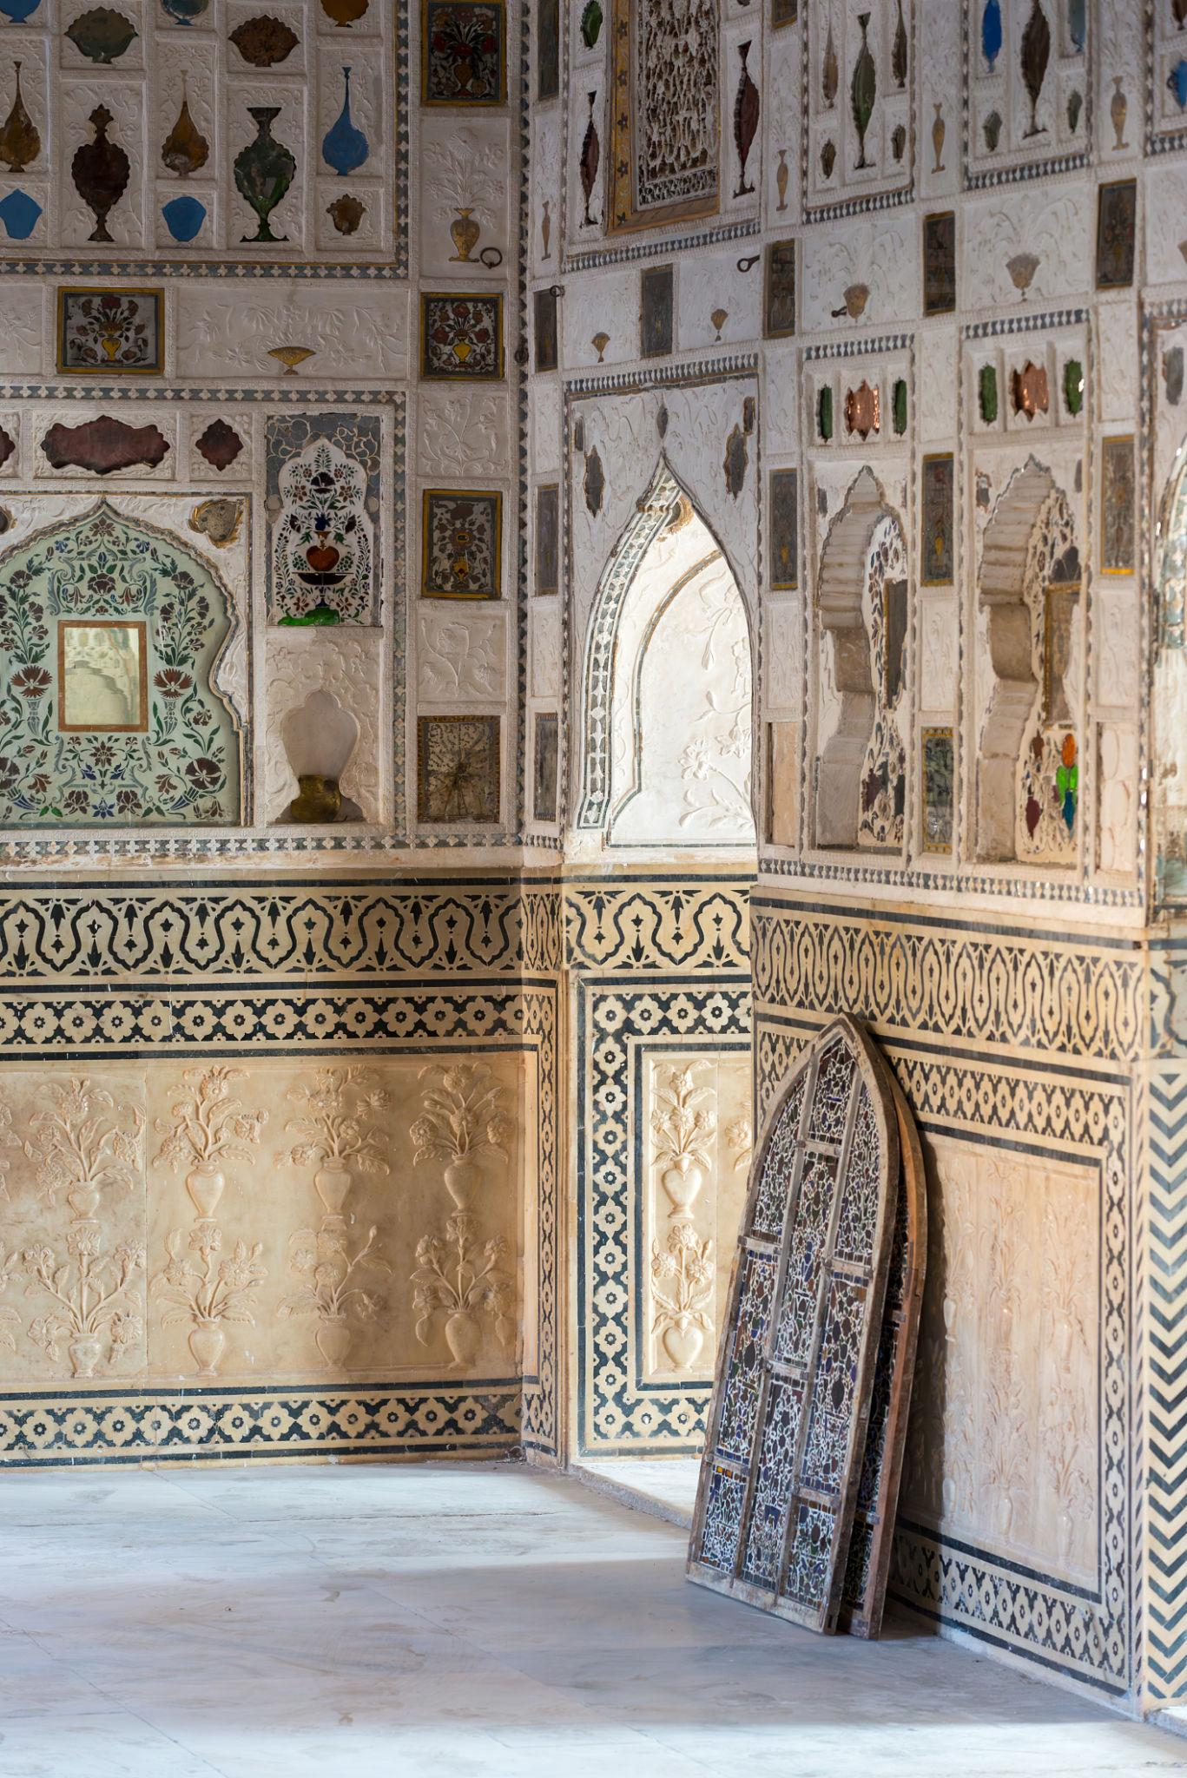
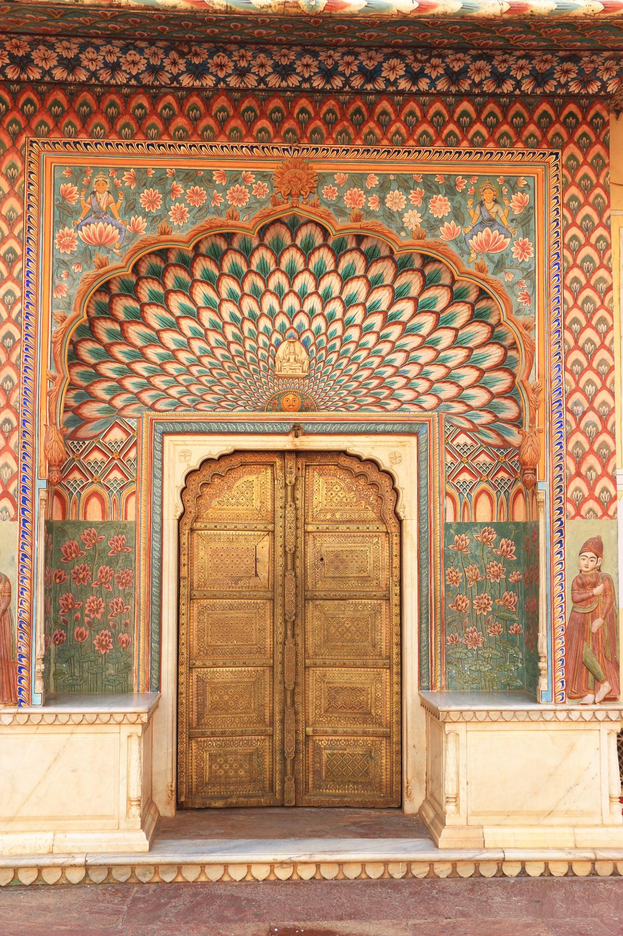
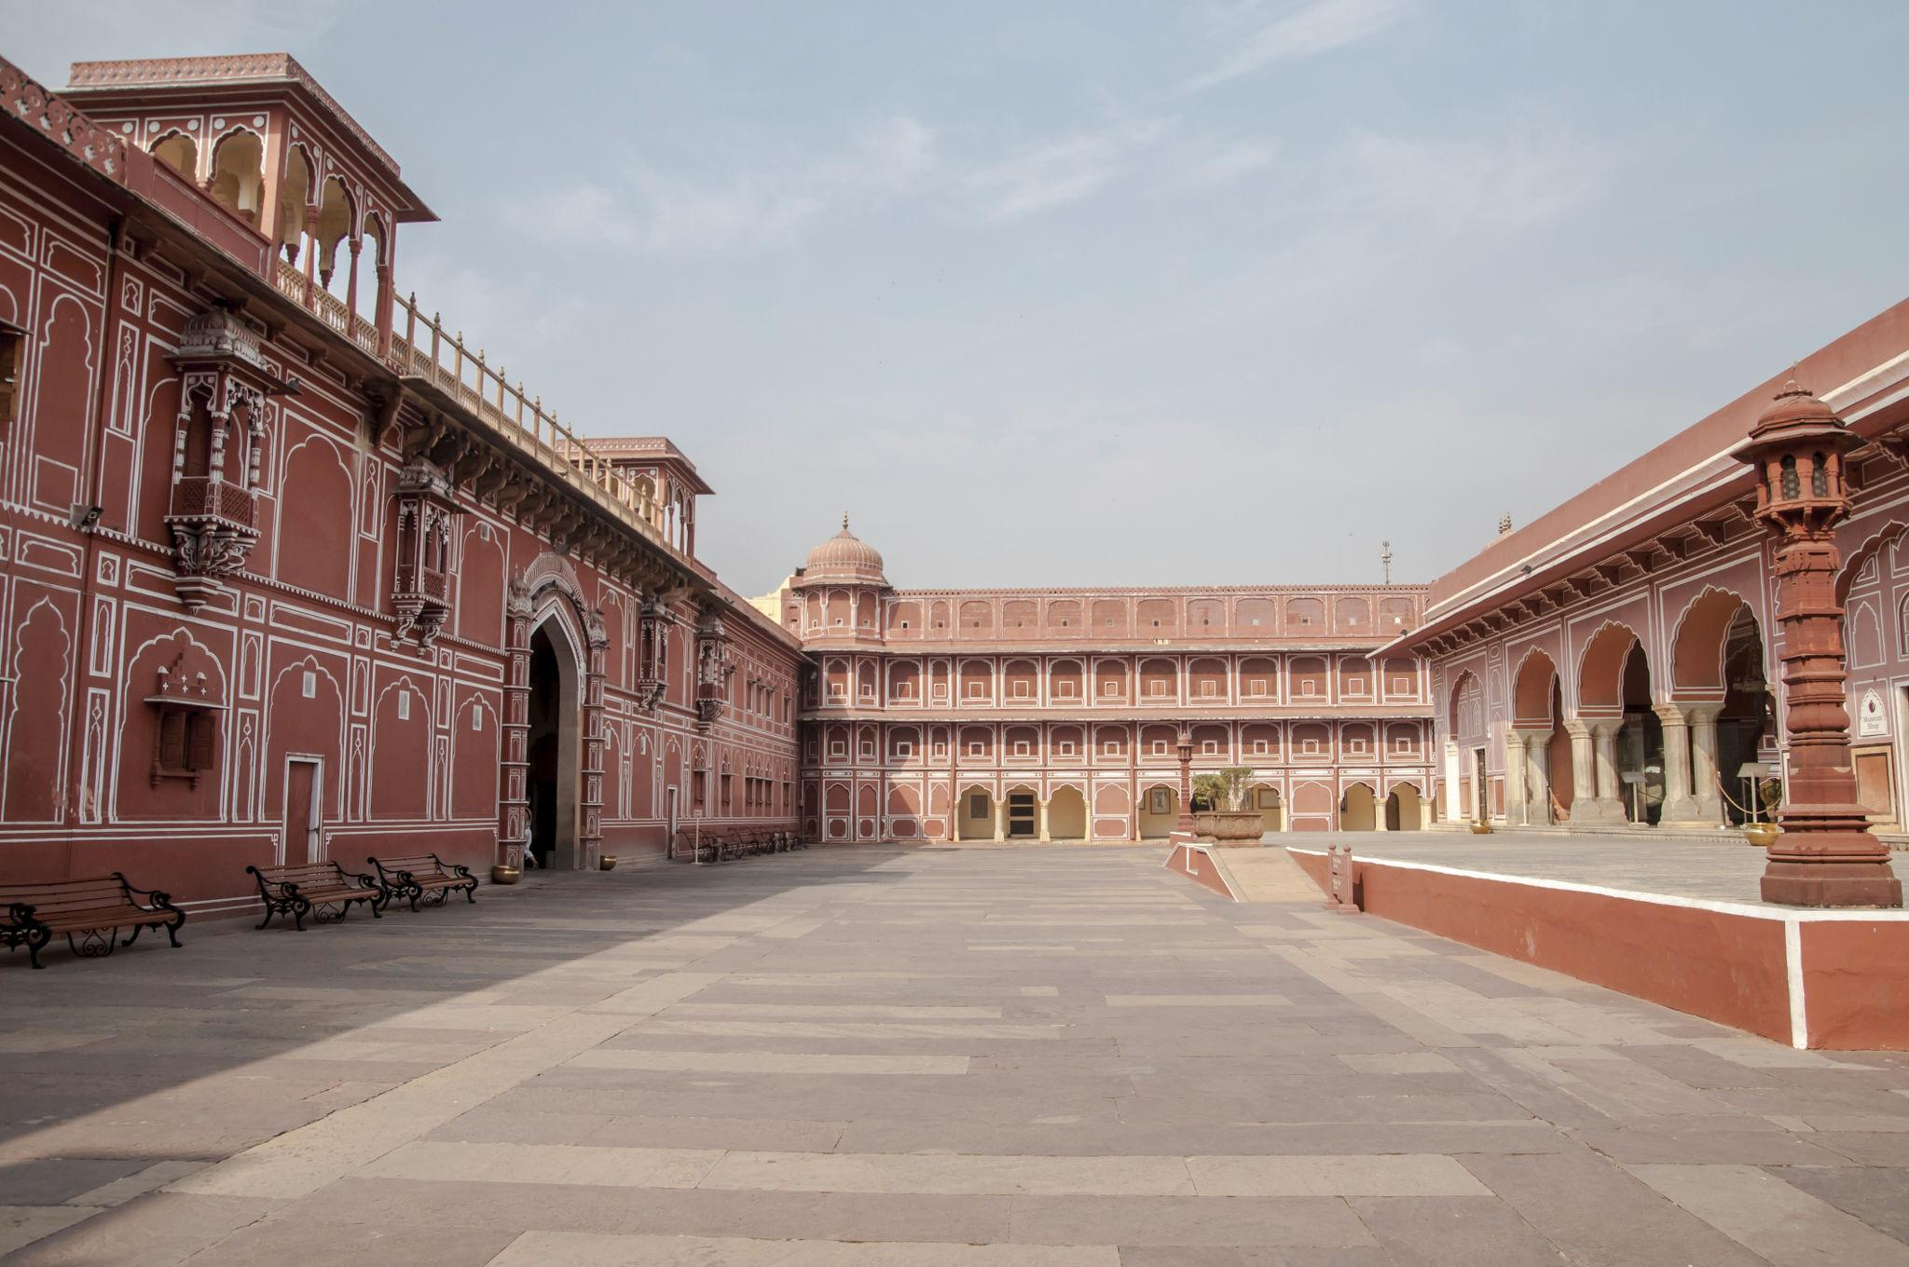
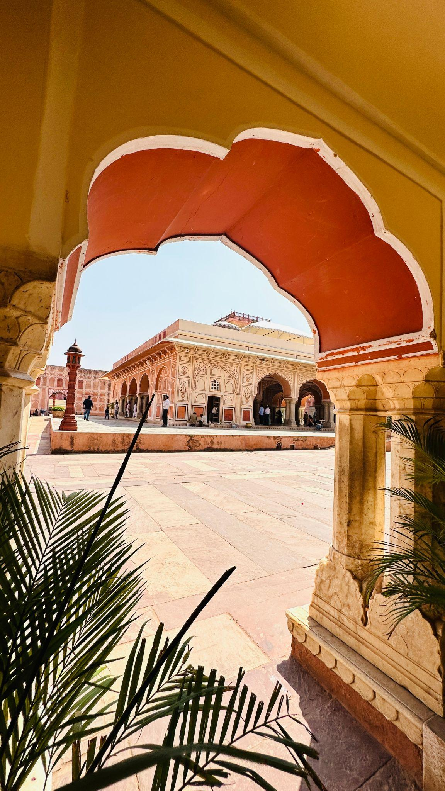

4. Jal Mahal
A stunning palace situated in the middle of Man Sagar Lake.
Best for:
- Sunset photography
- Scenic lake views
- Evening sightseeing
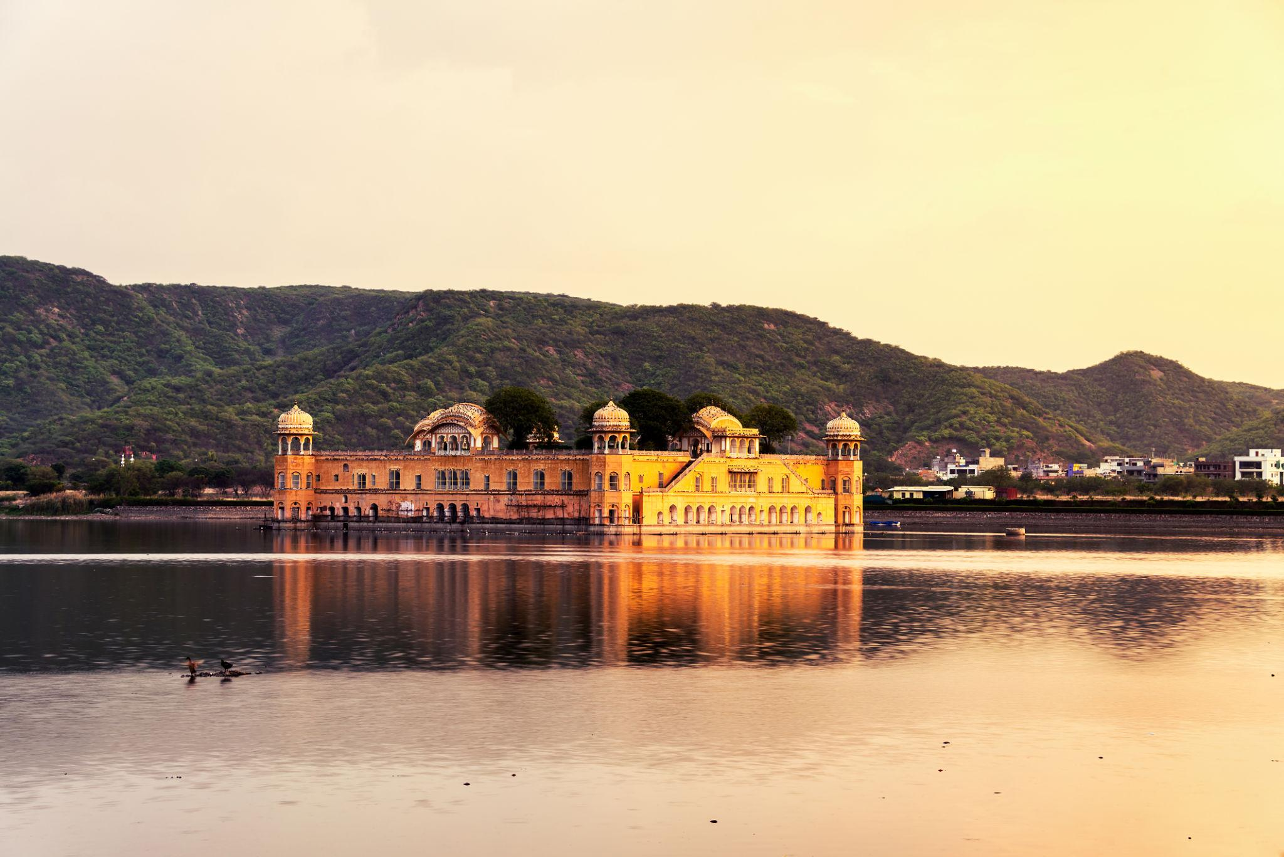
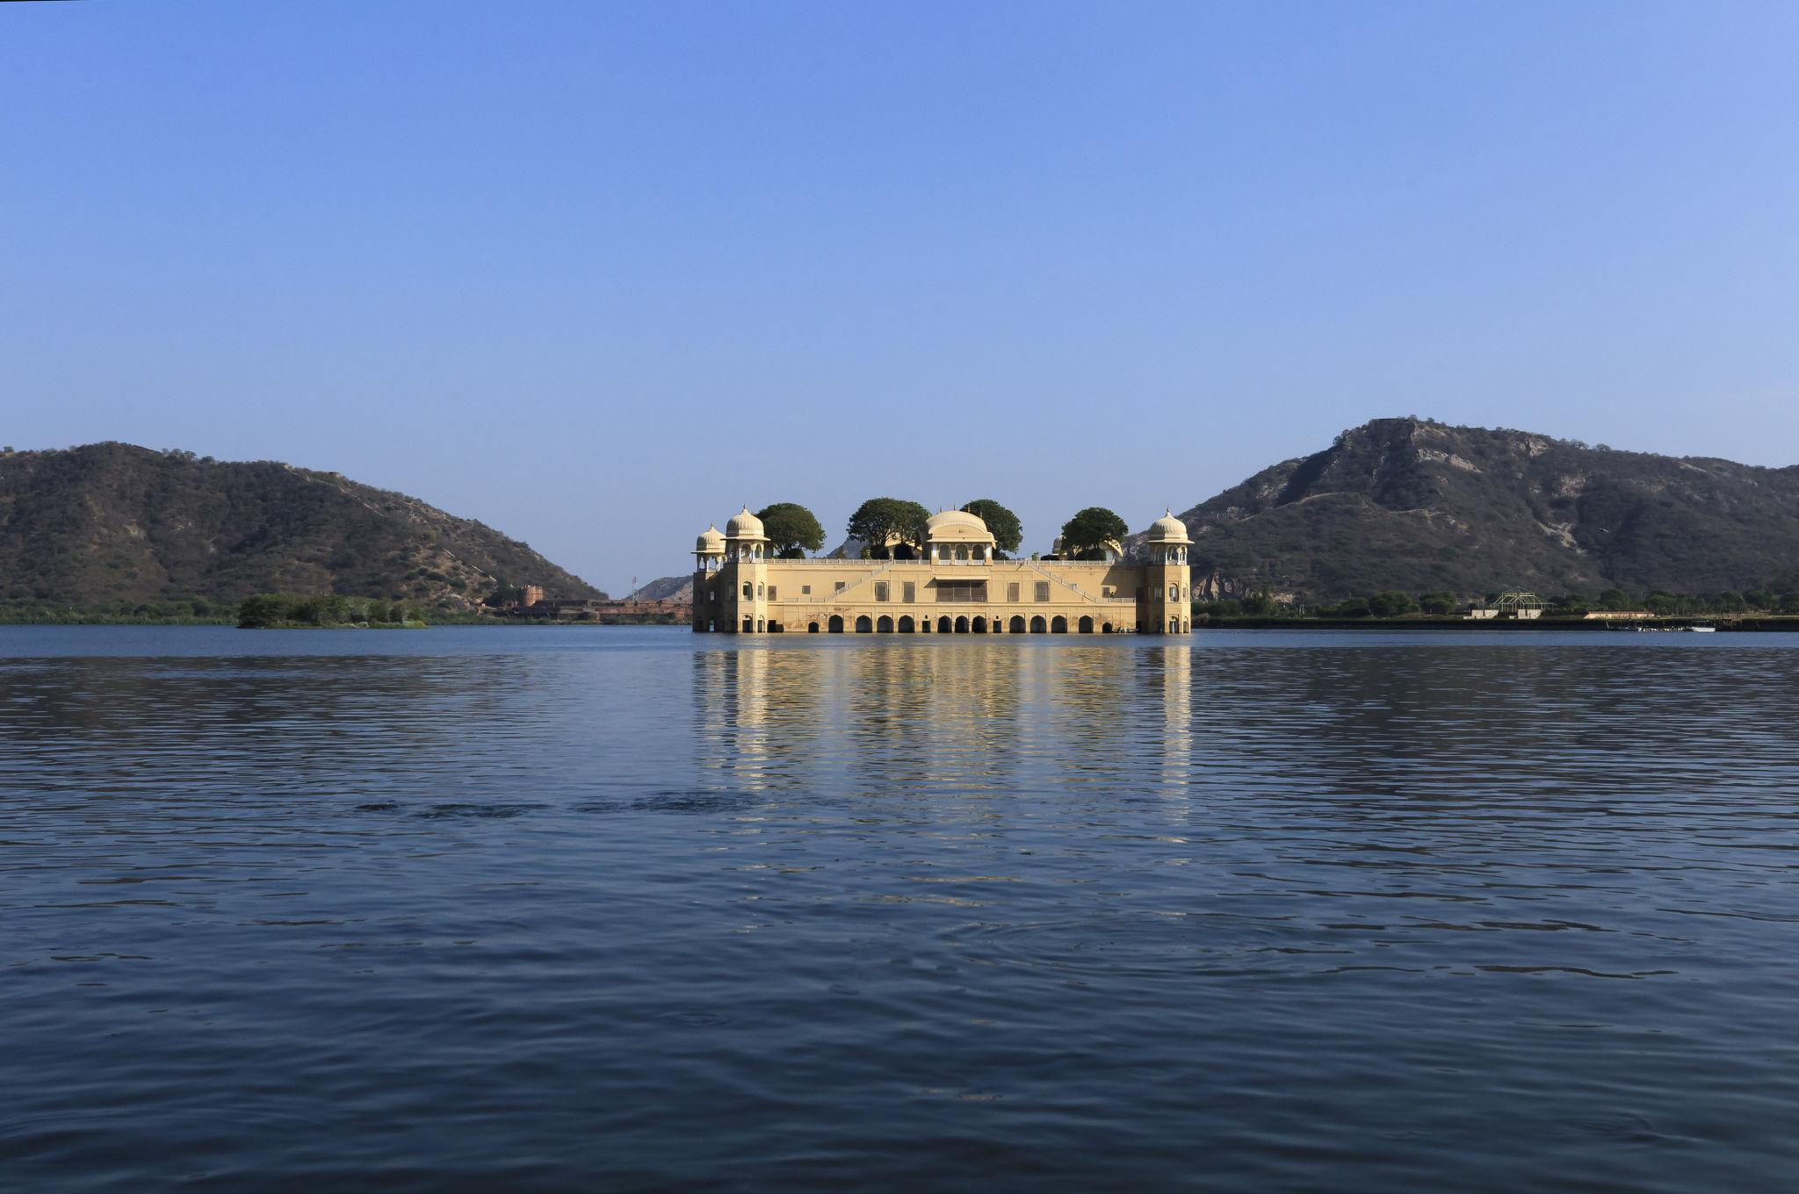
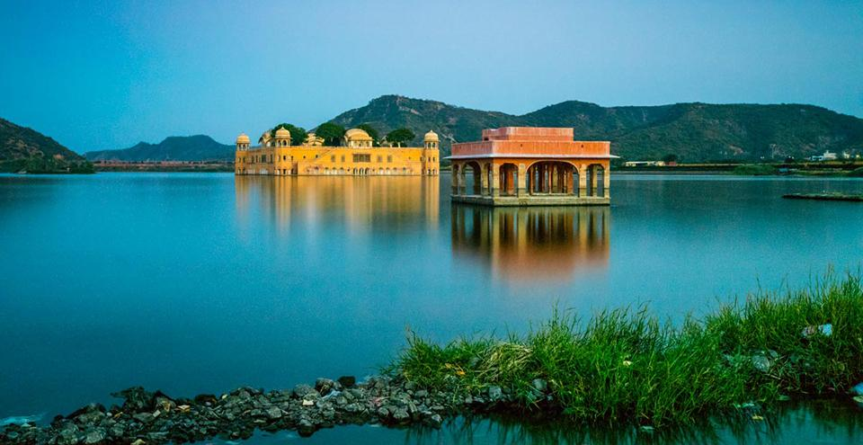
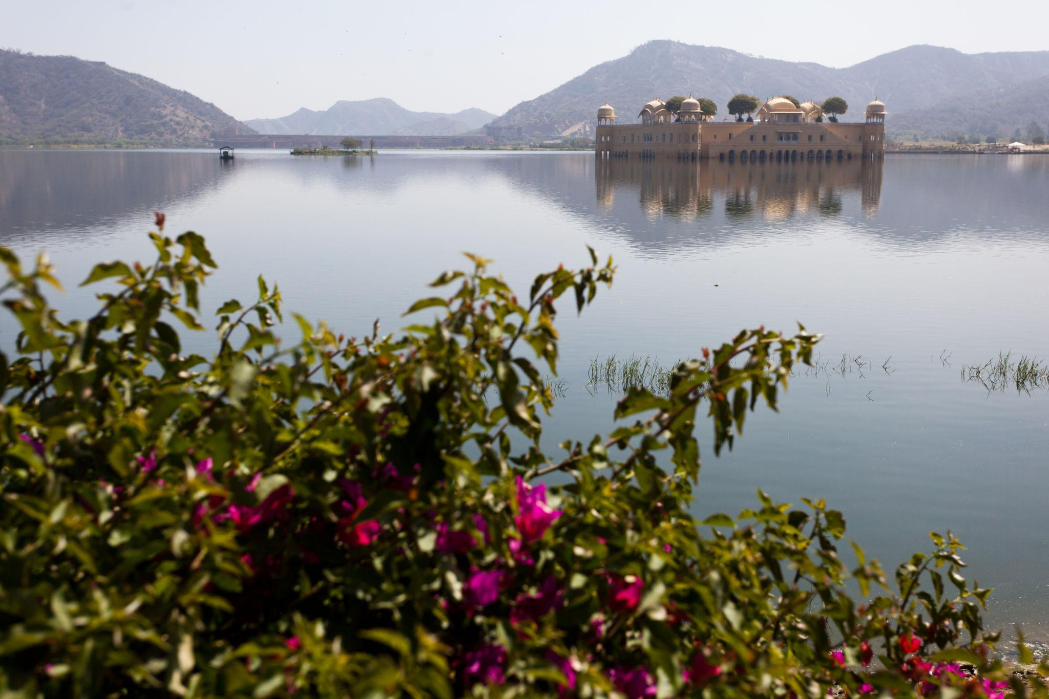
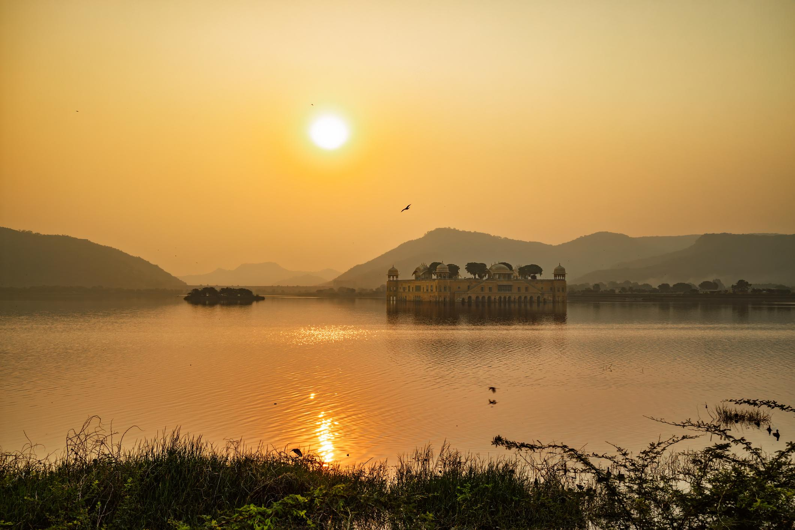
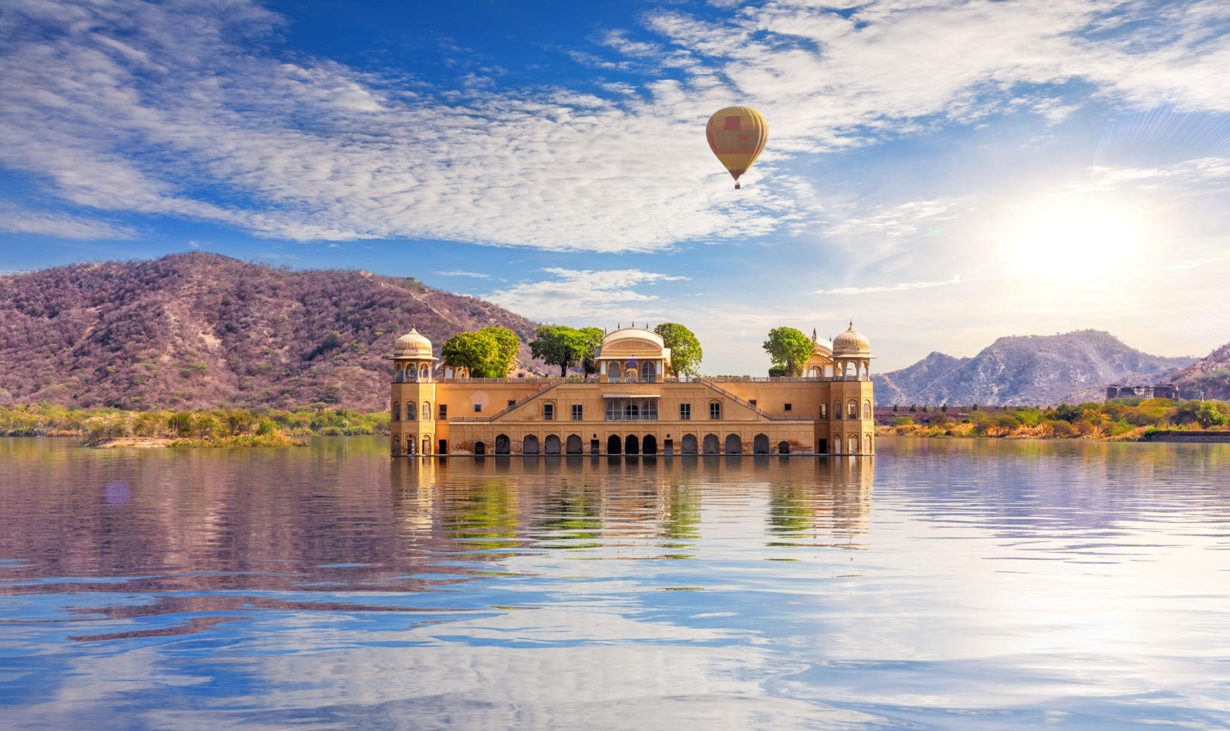

5. Jantar Mantar
A UNESCO World Heritage astronomical observatory built by Maharaja Sawai Jai Singh II.
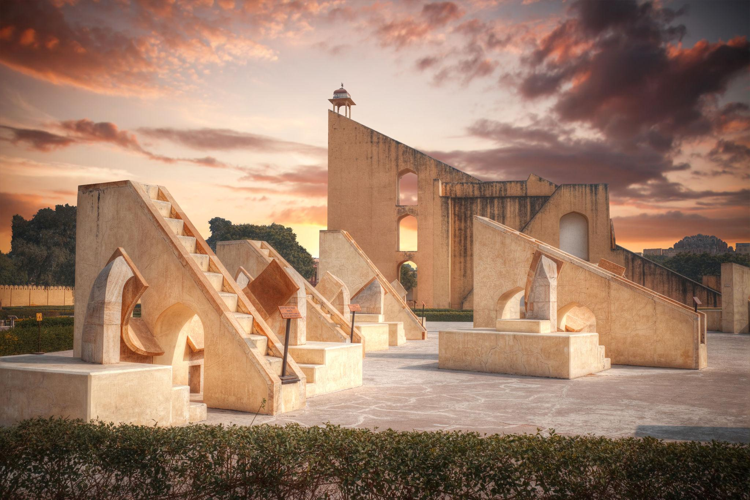
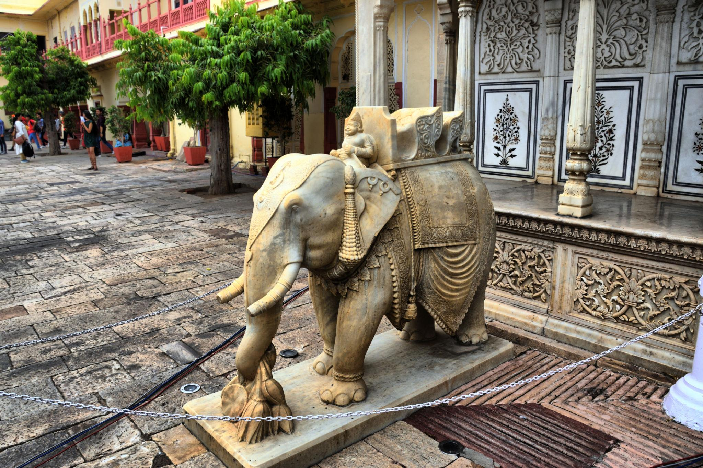
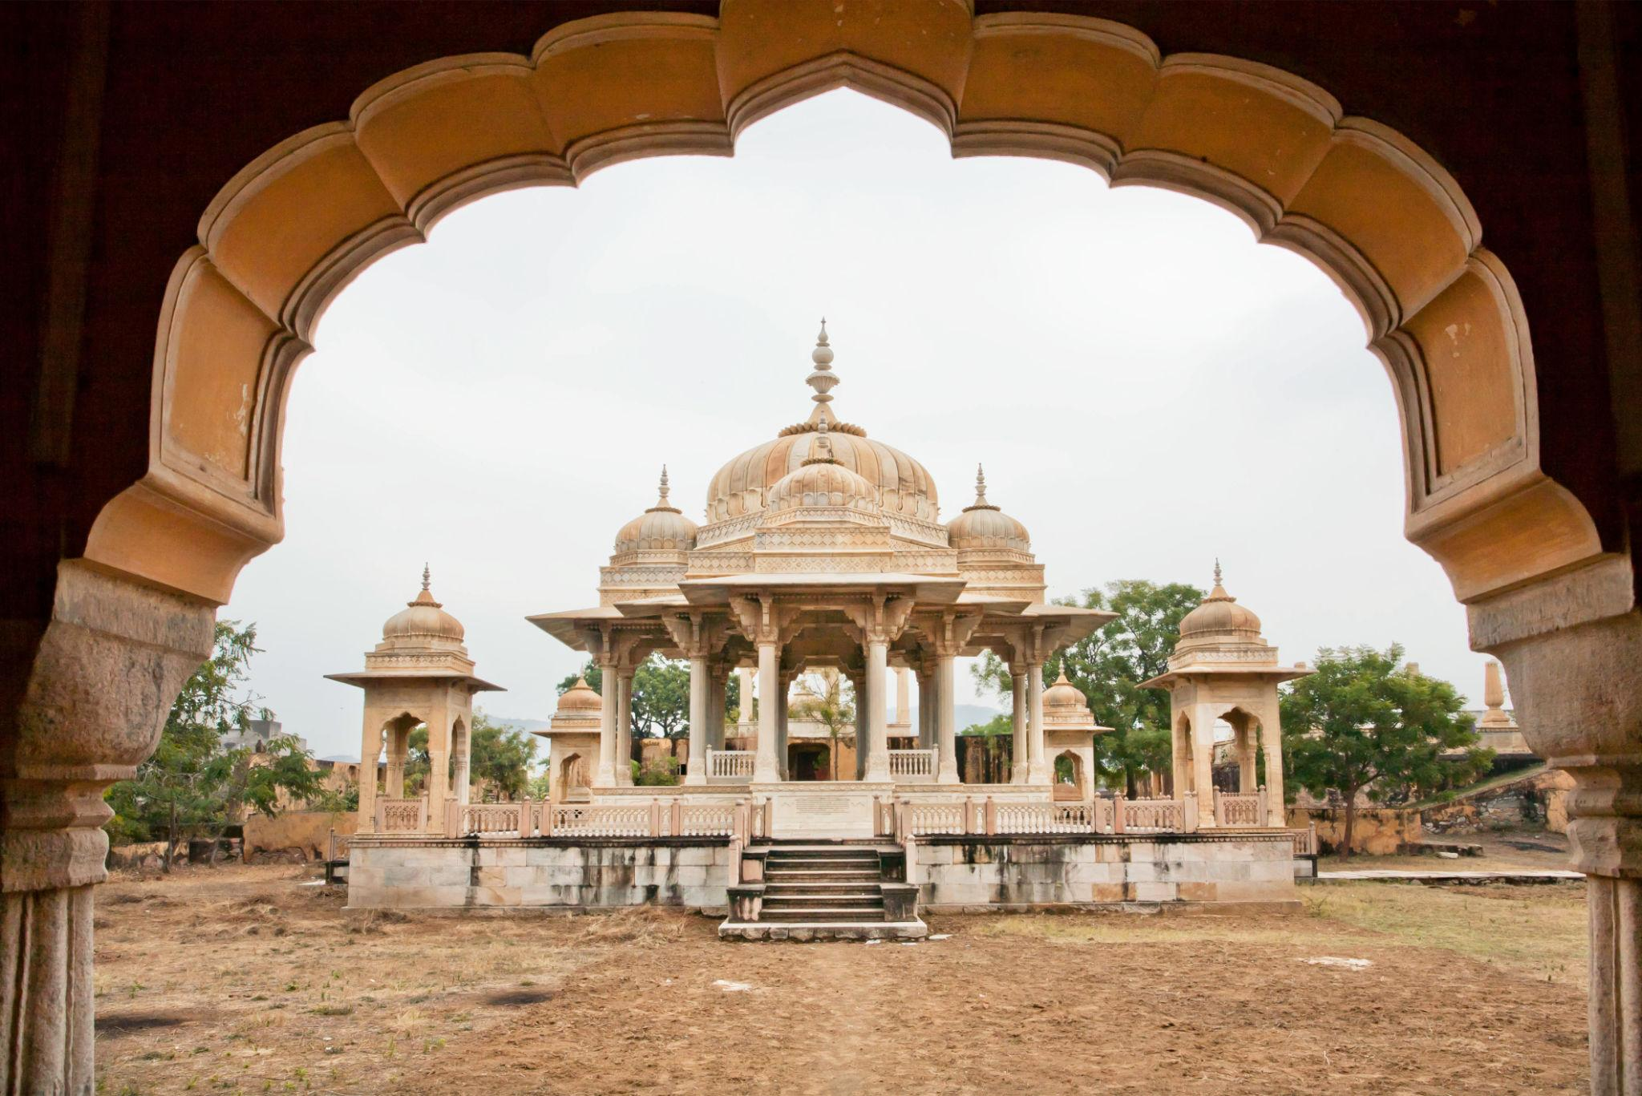
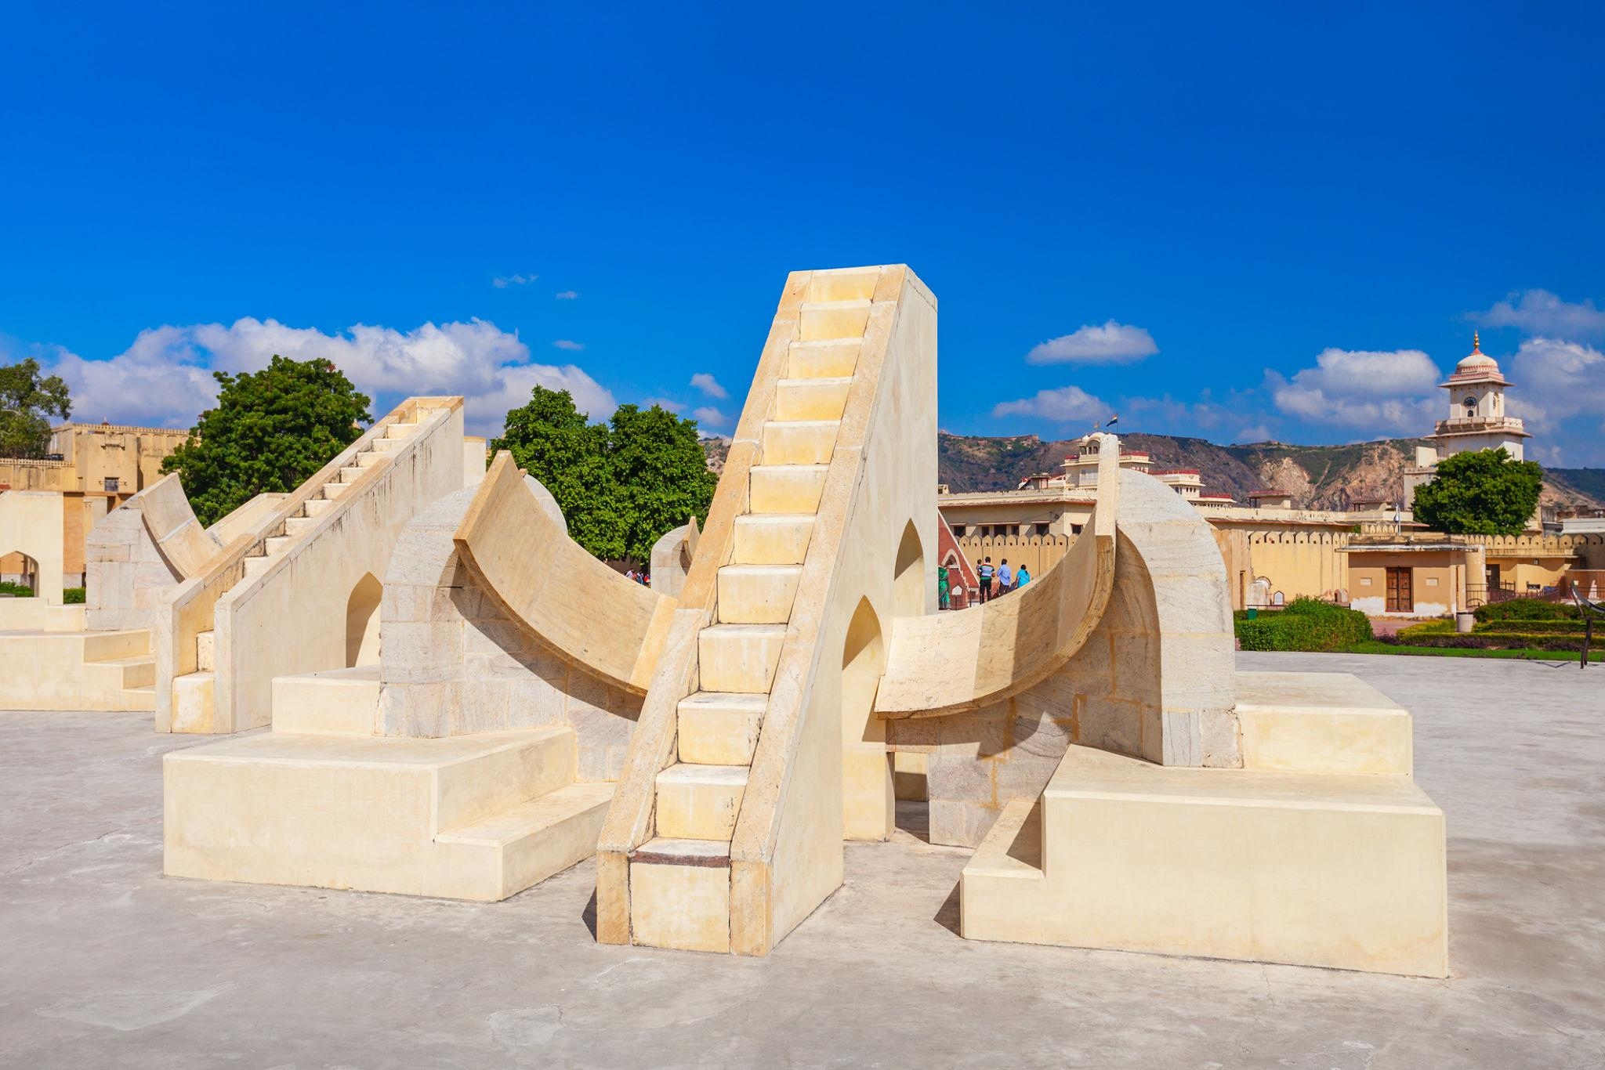
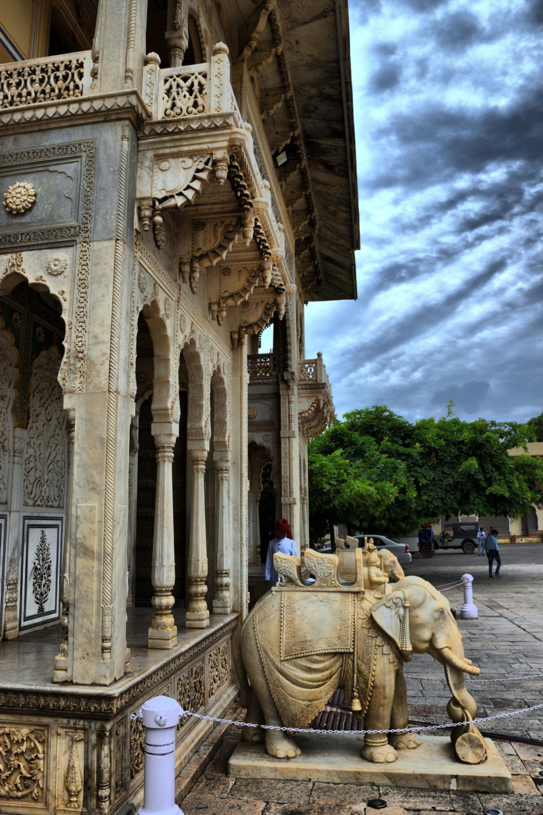
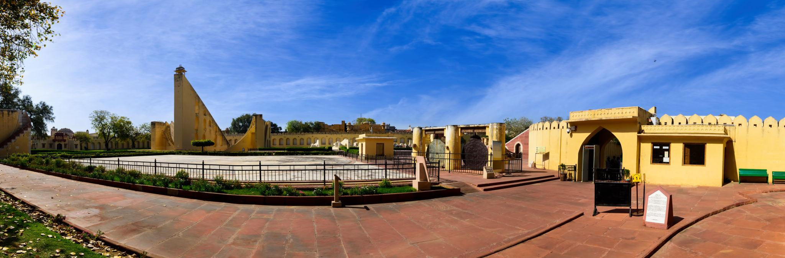

6. Nahargarh Fort
A hilltop fort offering breathtaking panoramic views of Jaipur city.
Popular for:
- Sunset viewpoints
- City skyline photography
- Café & evening views
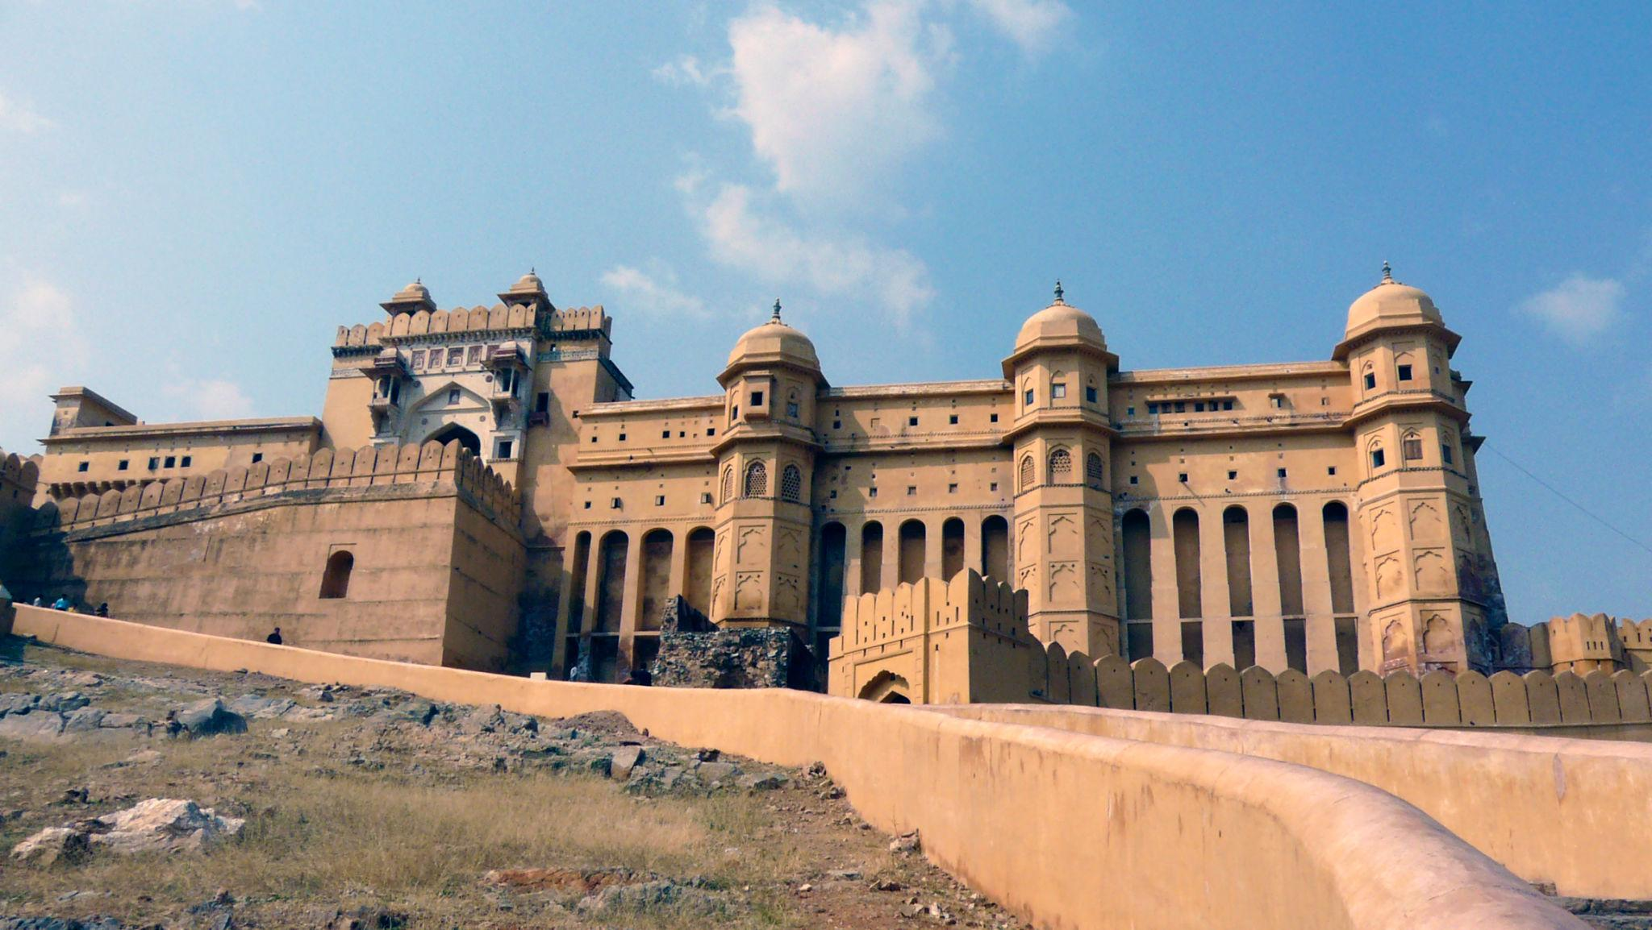
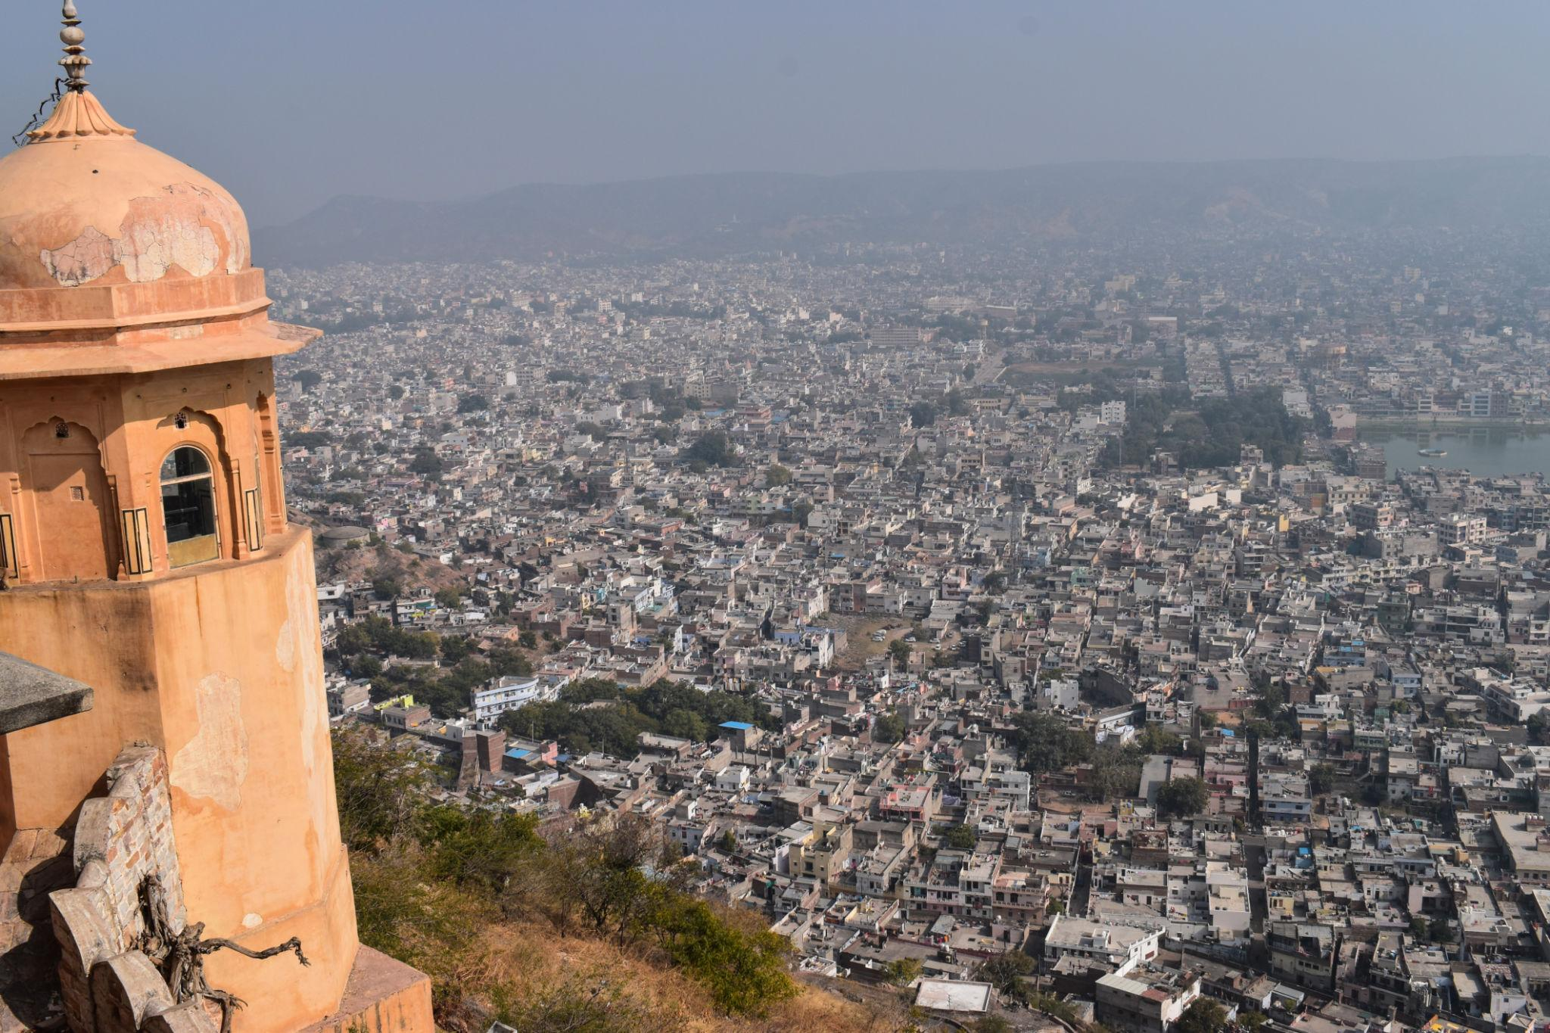
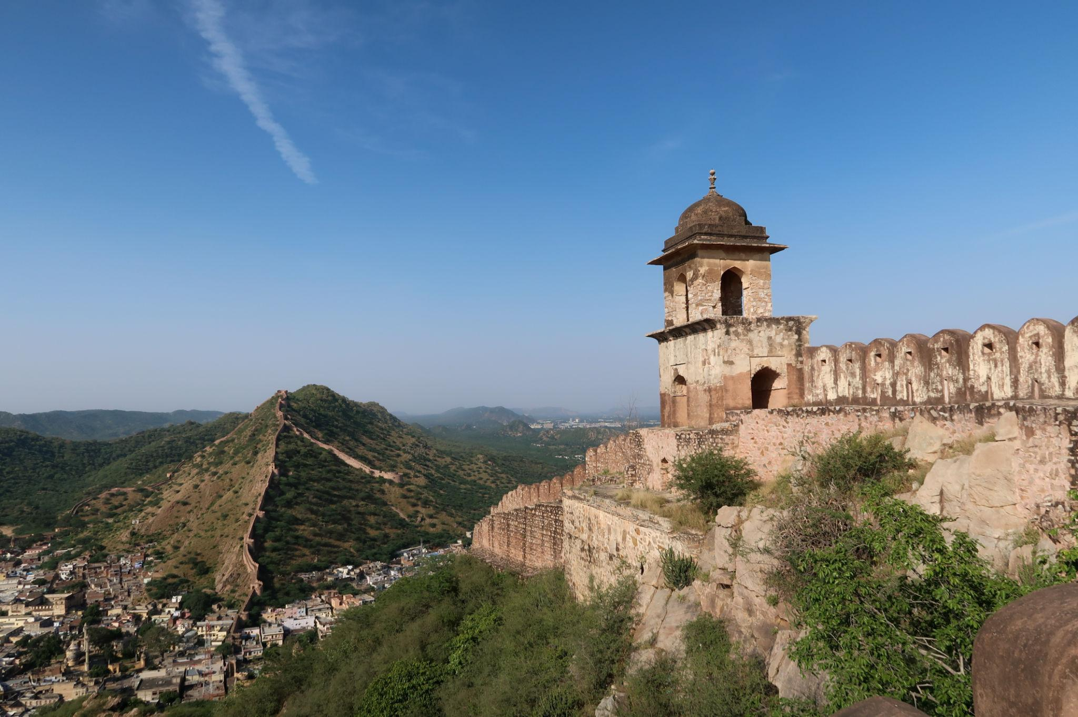
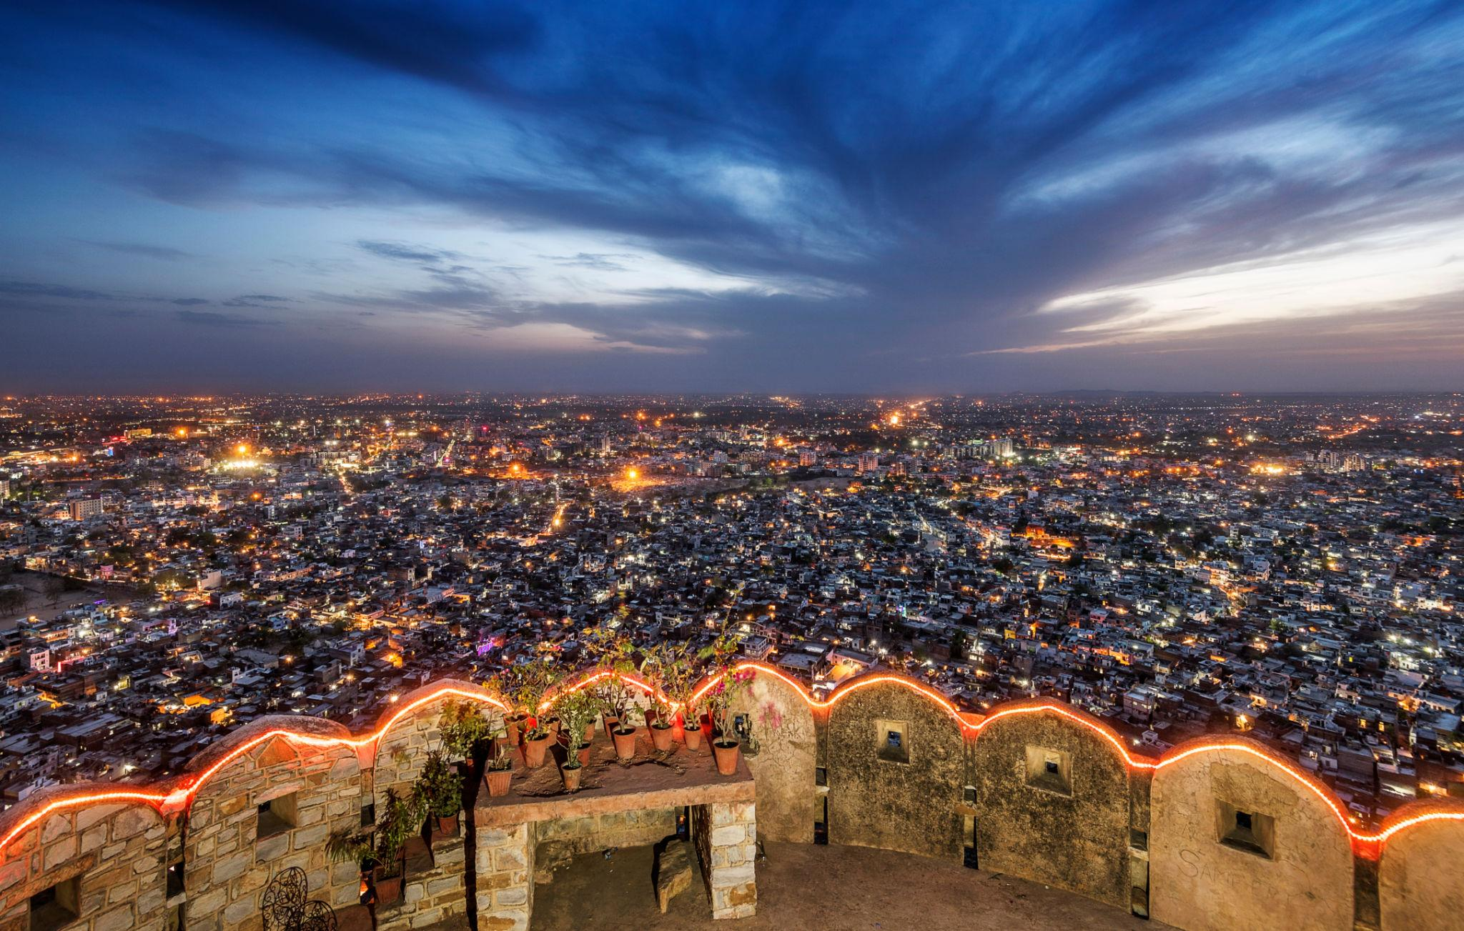
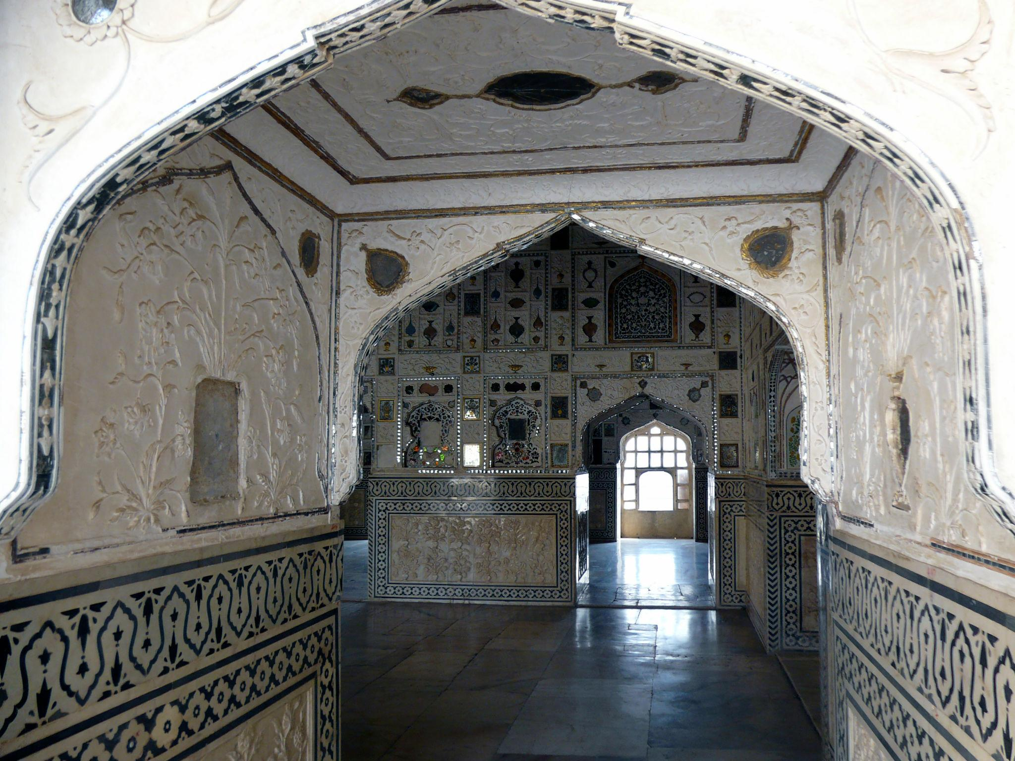
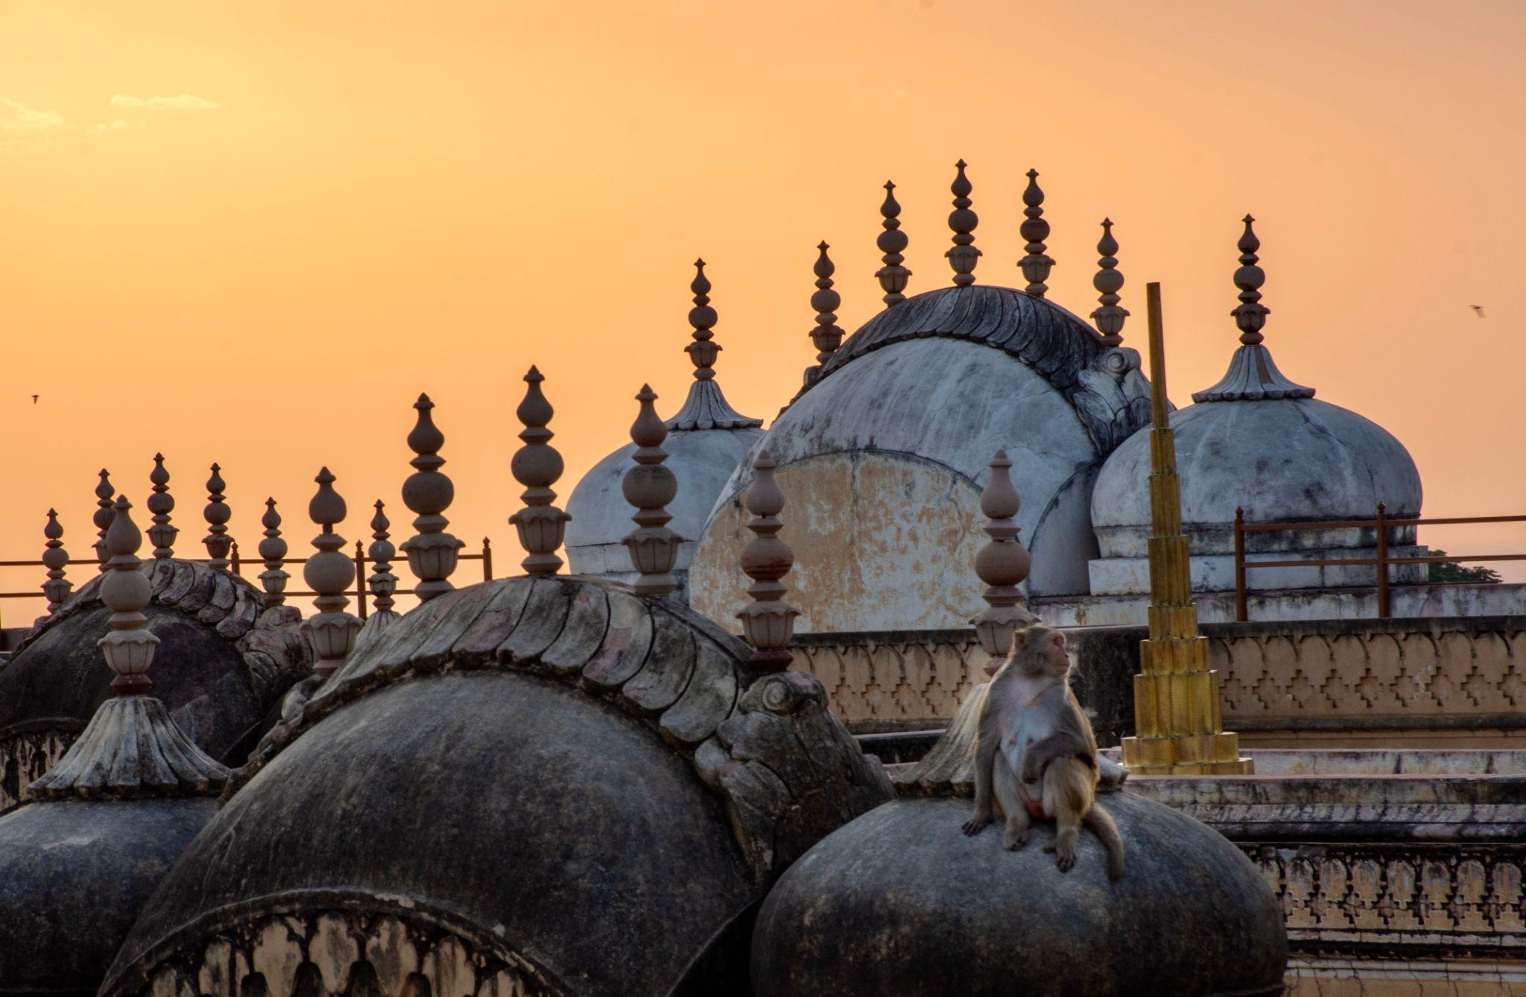
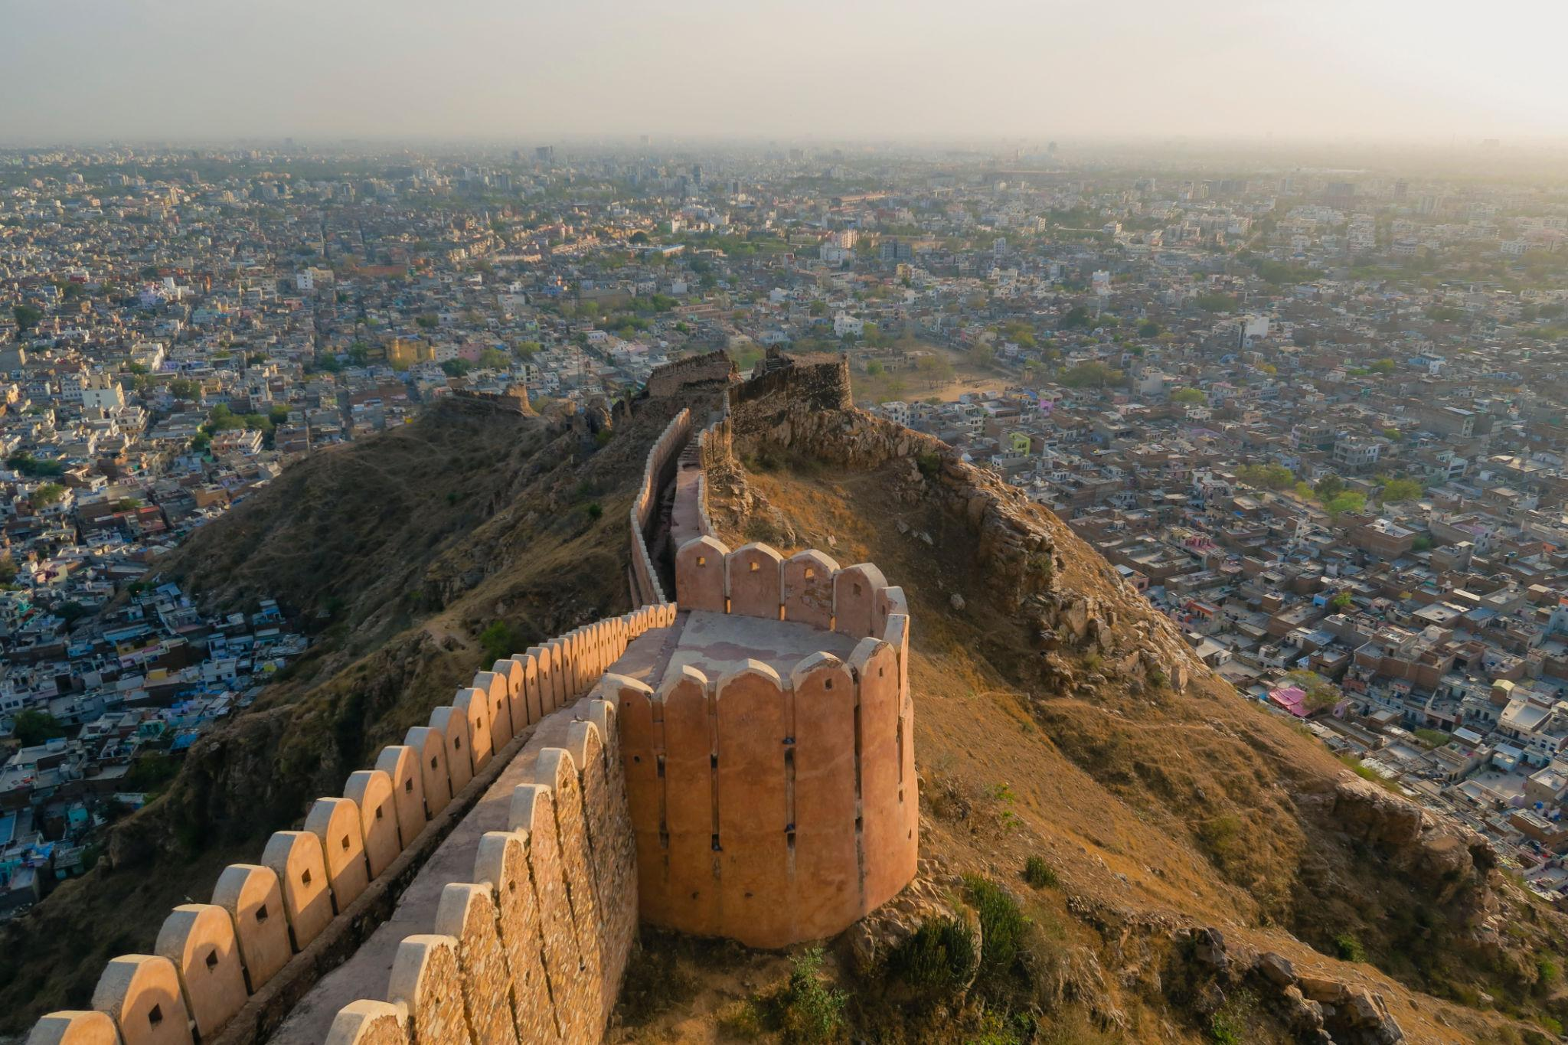
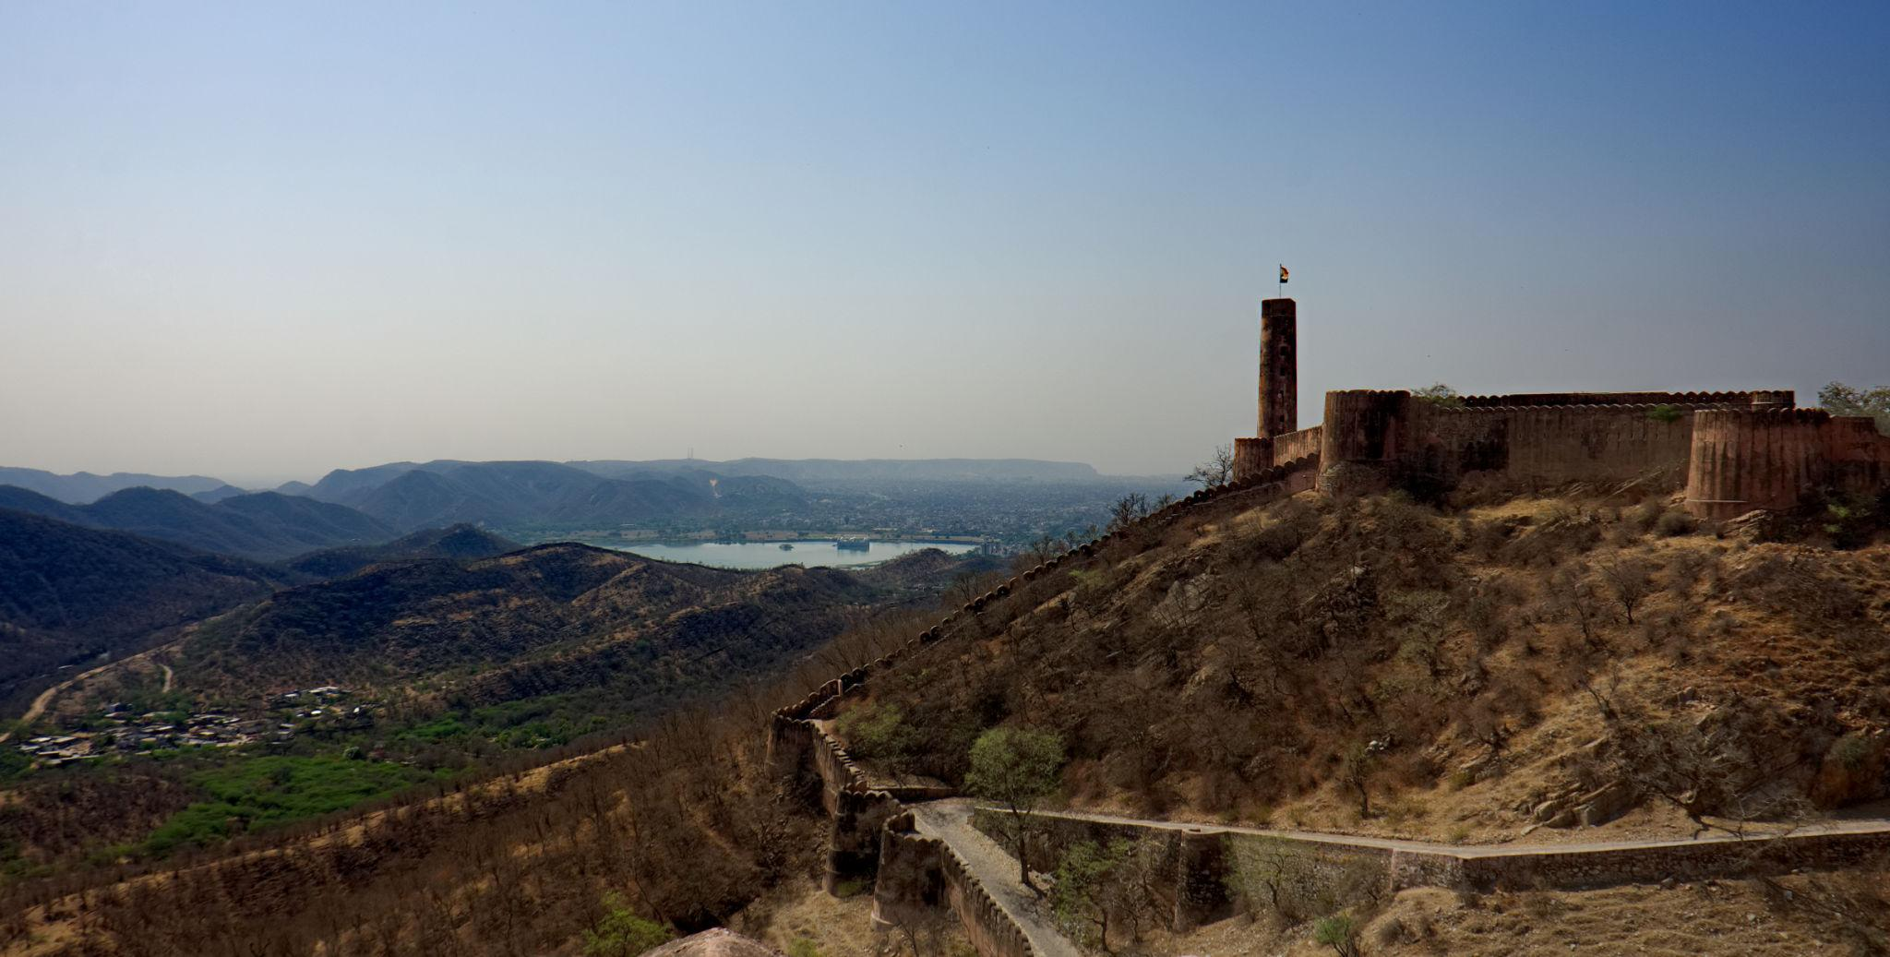

Best Things to Do in Jaipur
- Explore royal forts & palaces
- Shop in colorful local bazaars
- Enjoy Rajasthani cultural performances
- Ride elephants at Amber Fort
- Taste authentic Rajasthani cuisine
- Stay in luxury heritage hotels
- Experience traditional folk music & dance
- Watch sunset from Nahargarh Fort

Famous Markets & Shopping in Jaipur 🛍️
Popular Shopping Areas:
- Johari Bazaar
- Bapu Bazaar
- Tripolia Bazaar
- Chandpole Market
Famous items:
- Traditional jewelry
- Handicrafts
- Bandhani fabrics
- Mojari footwear
- Blue pottery
- Marble handicrafts
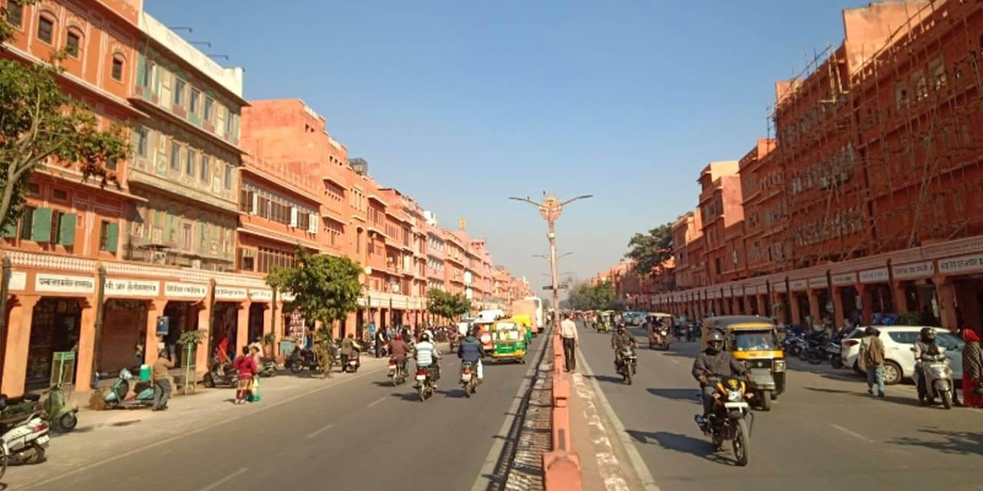
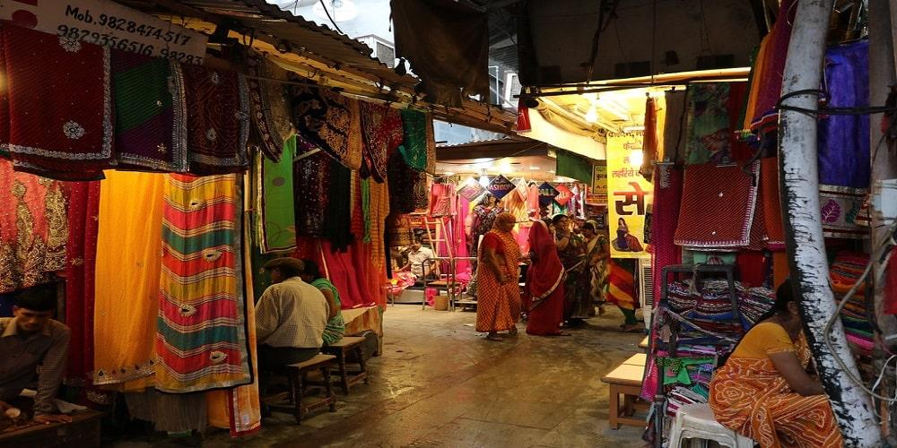
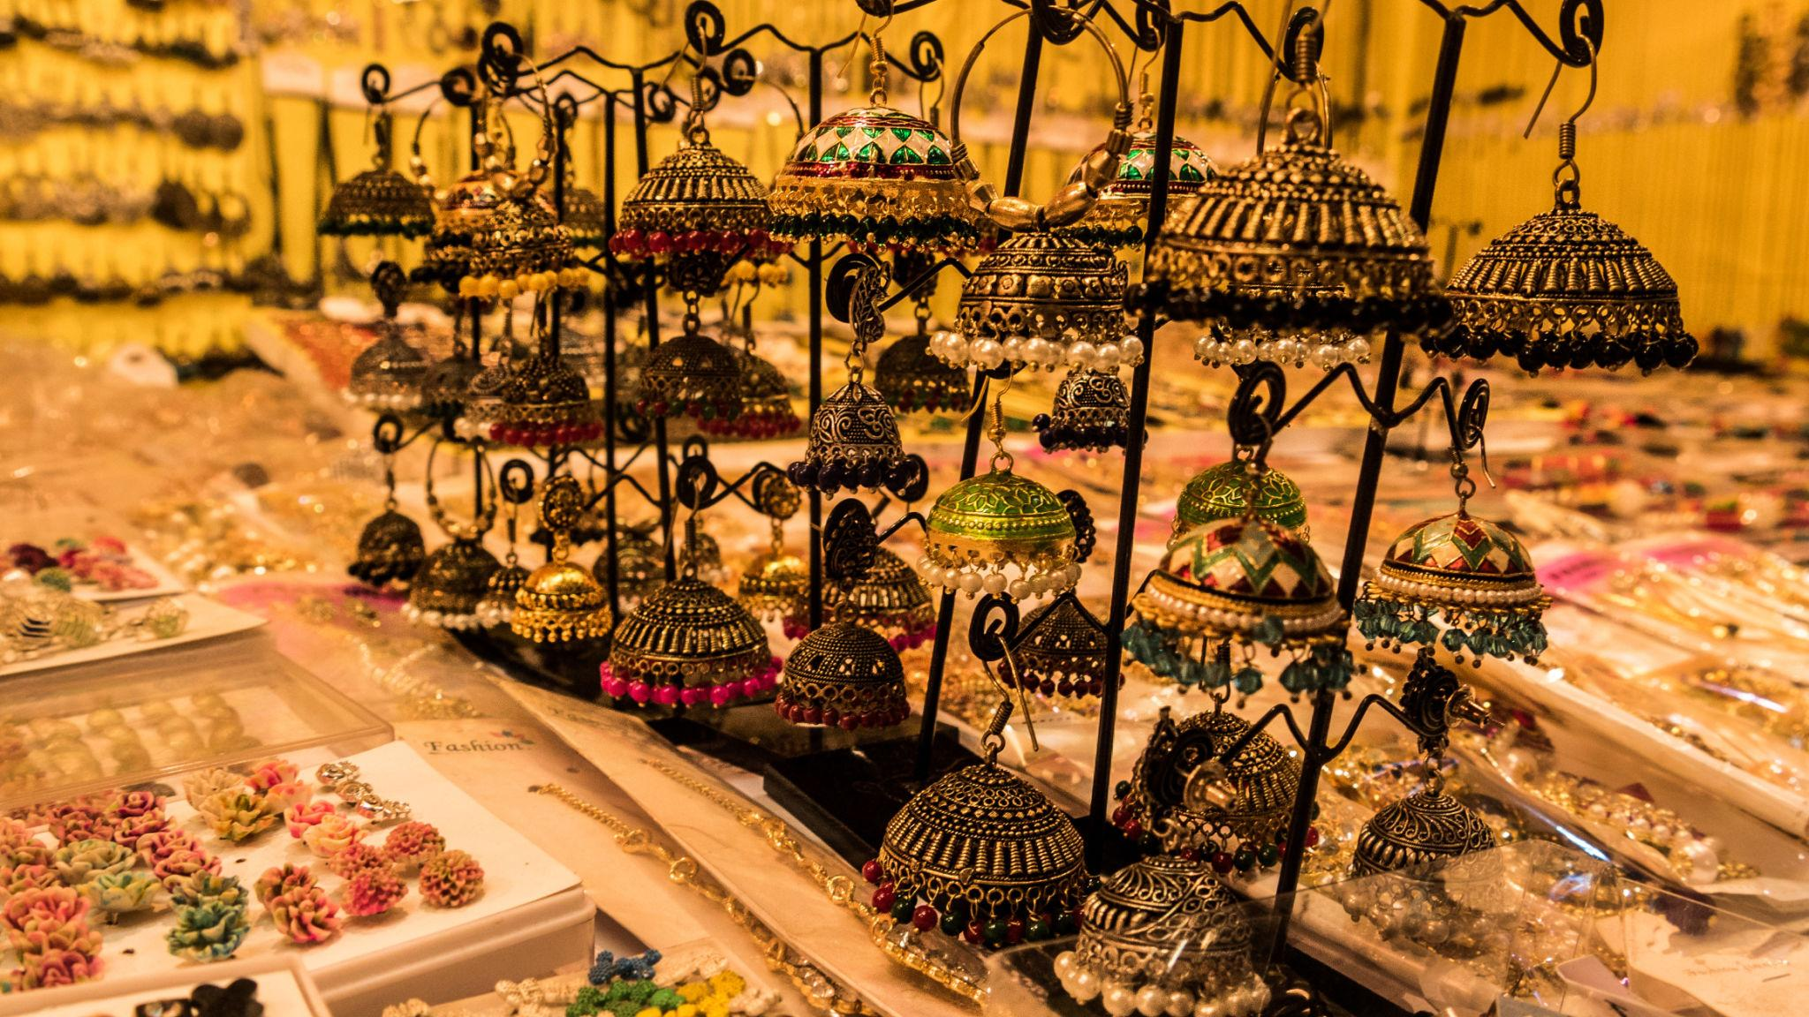
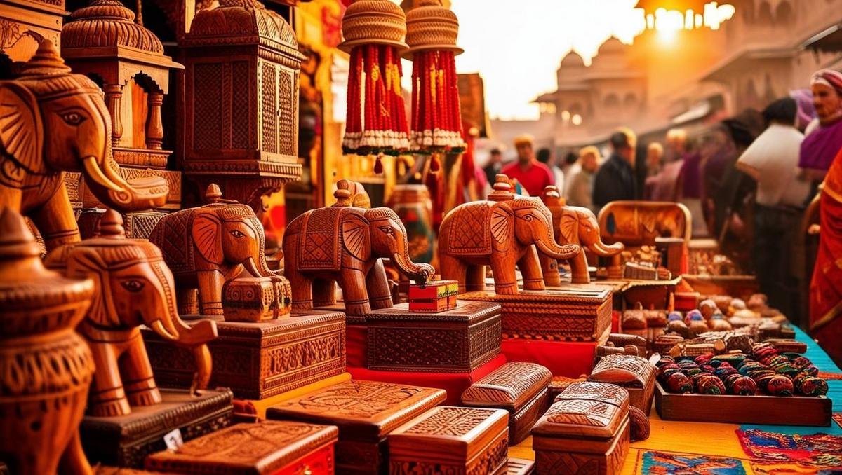
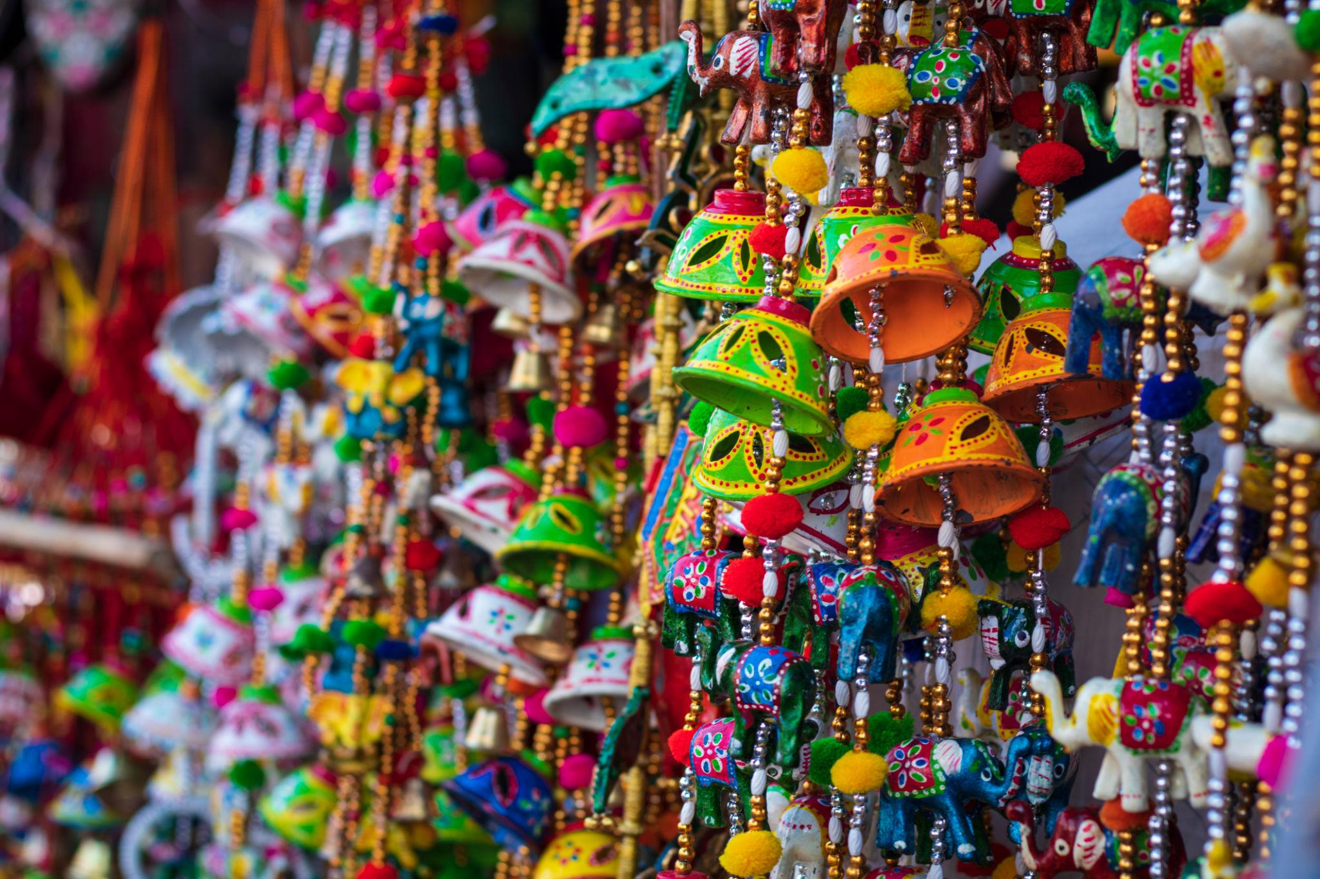
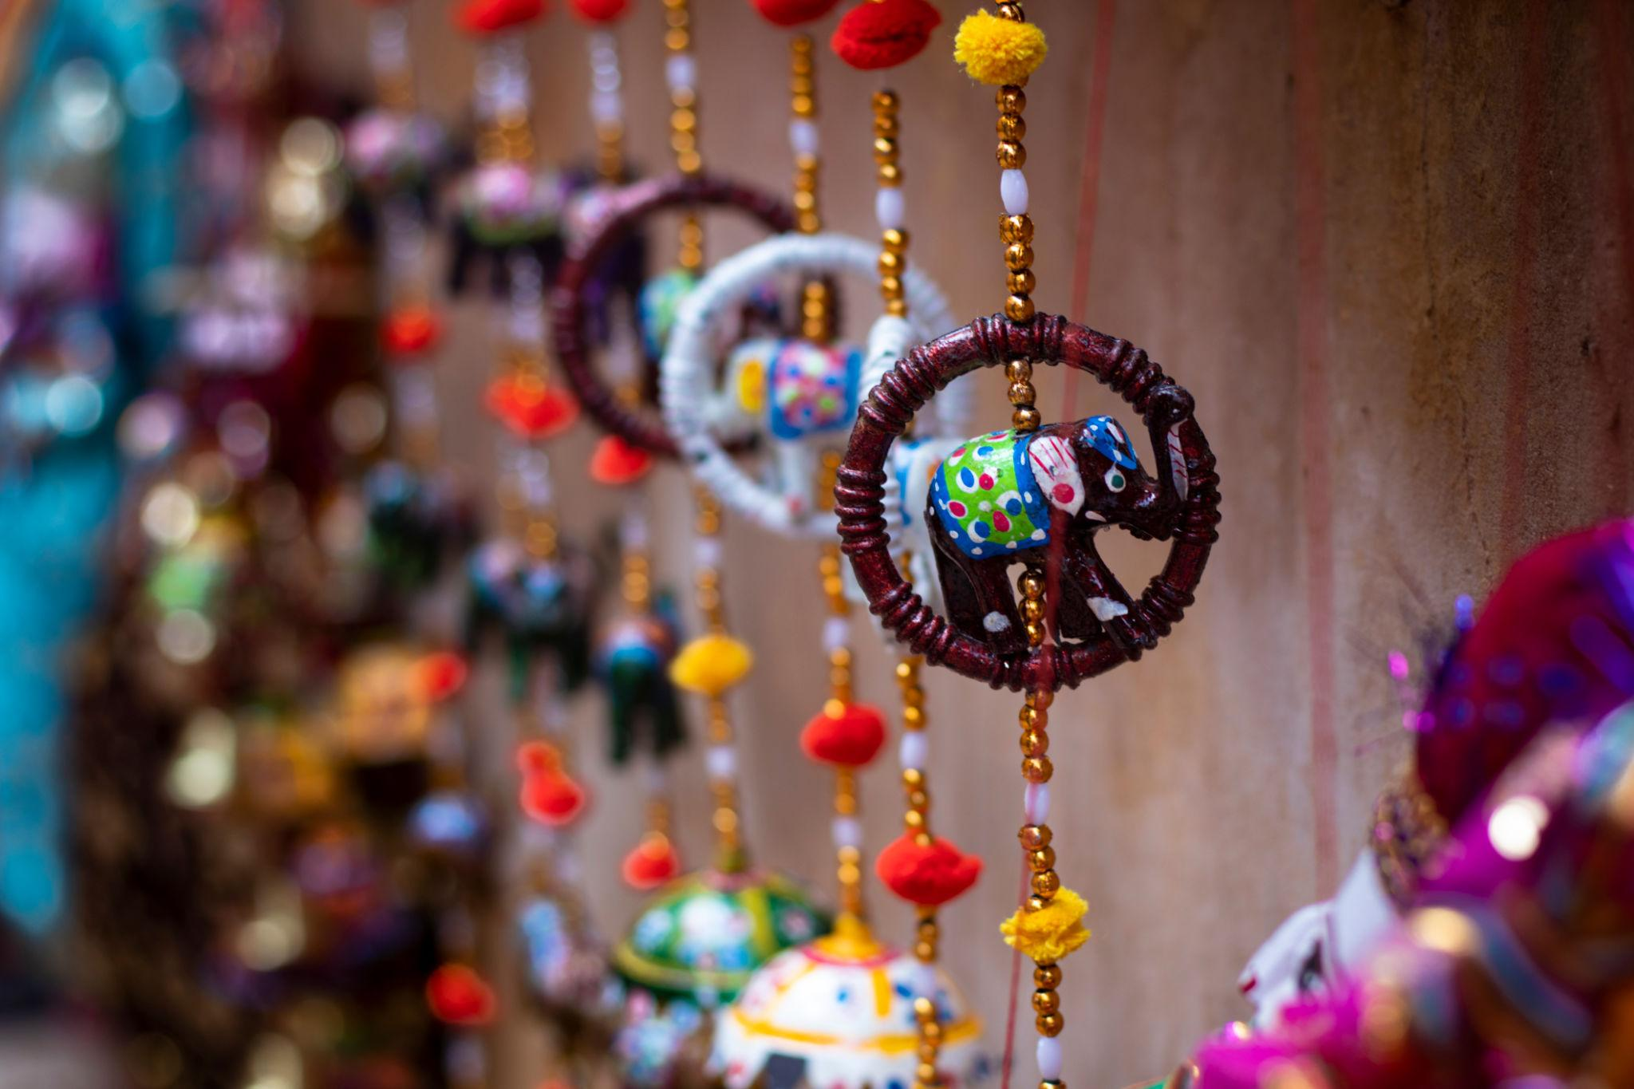
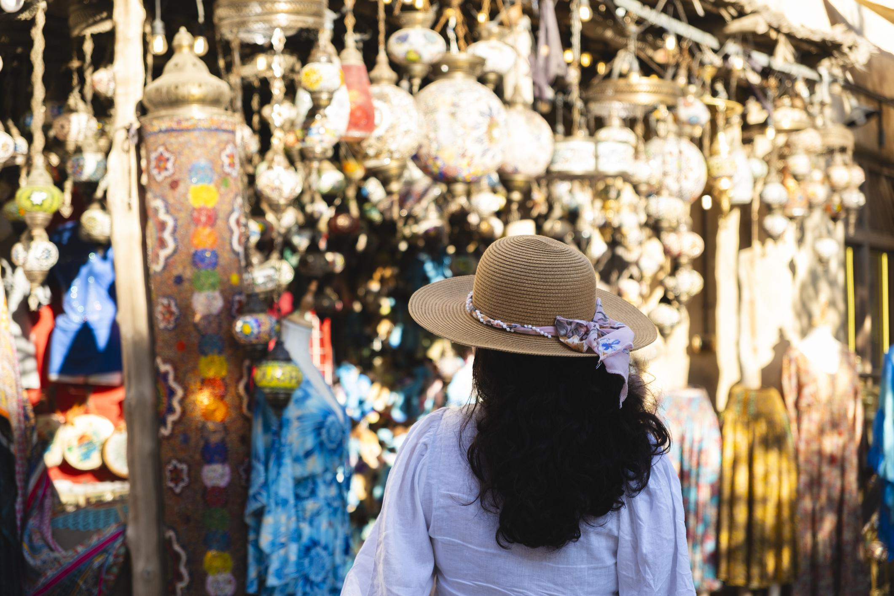

Best Time to Visit Jaipur
Season | Months | Weather
Winter | October – March | Pleasant & best for sightseeing
Summer | April – June | Very hot
Monsoon | July – September | Moderate rainfall
Winter is the best season to visit Jaipur.

How to Reach Jaipur
By Air
Main airport:
- Jaipur International Airport
By Train
Jaipur is well connected by rail with:
- Delhi
- Mumbai
- Agra
- Ahmedabad
By Road
Excellent highway connectivity from:
- Delhi
- Agra
- Udaipur
- Jodhpur
Travel time from Delhi: approximately 5–6 hours by road.

Famous Foods to Try in Jaipur 🍴
- Dal Baati Churma
- Laal Maas
- Ghewar
- Pyaaz Kachori
- Ker Sangri
- Rajasthani Thali
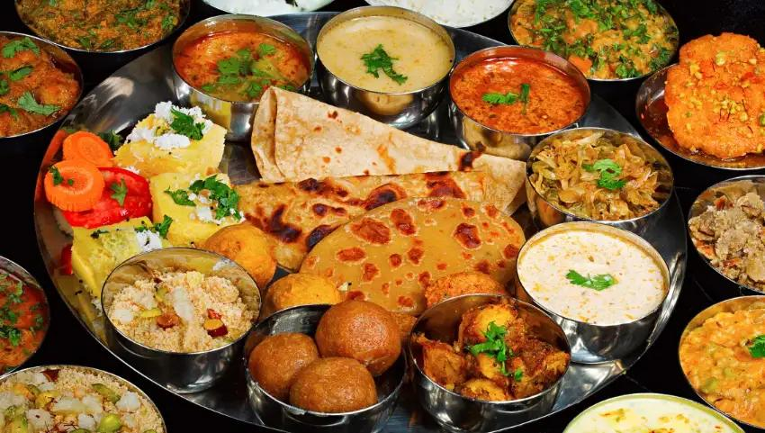
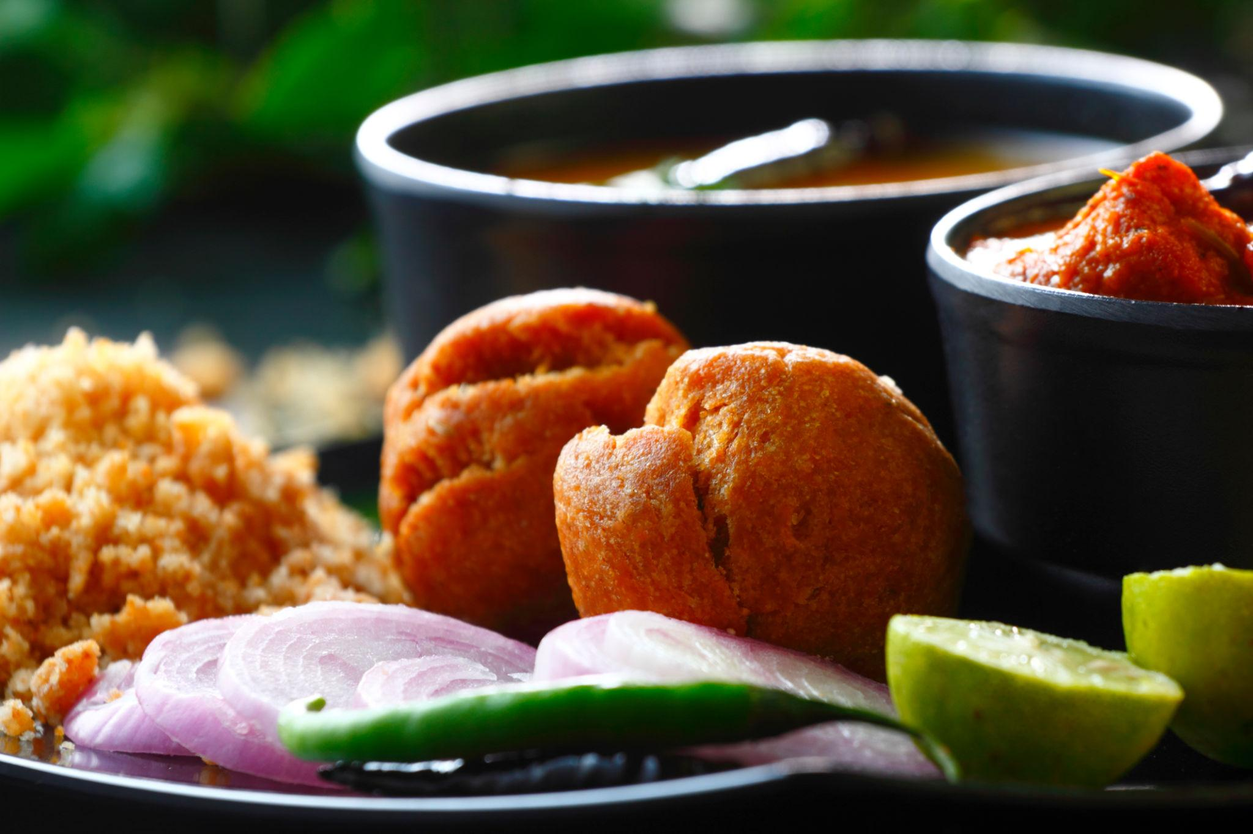
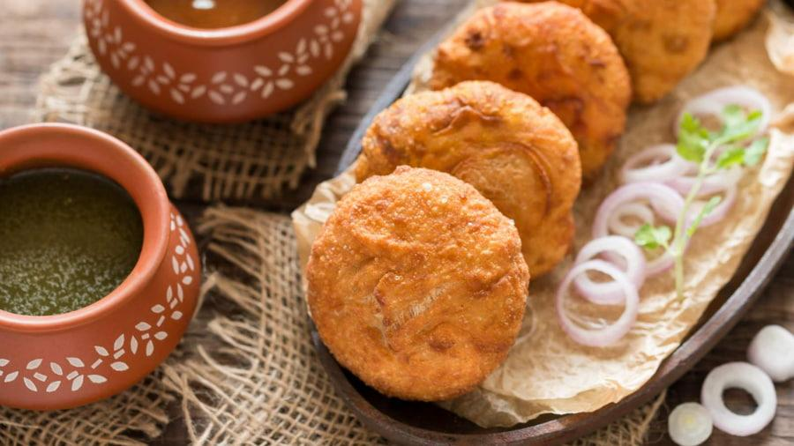
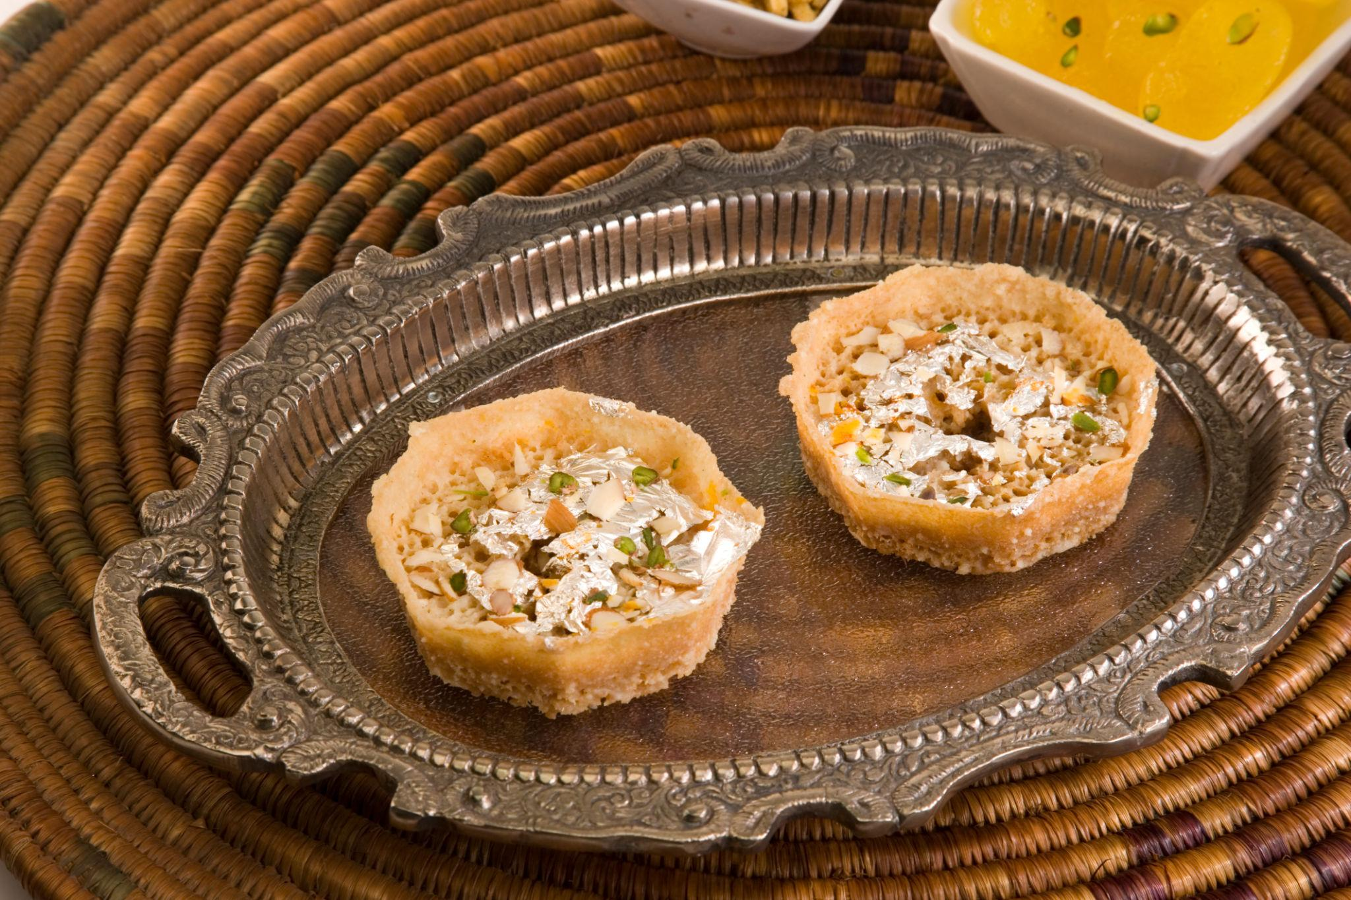
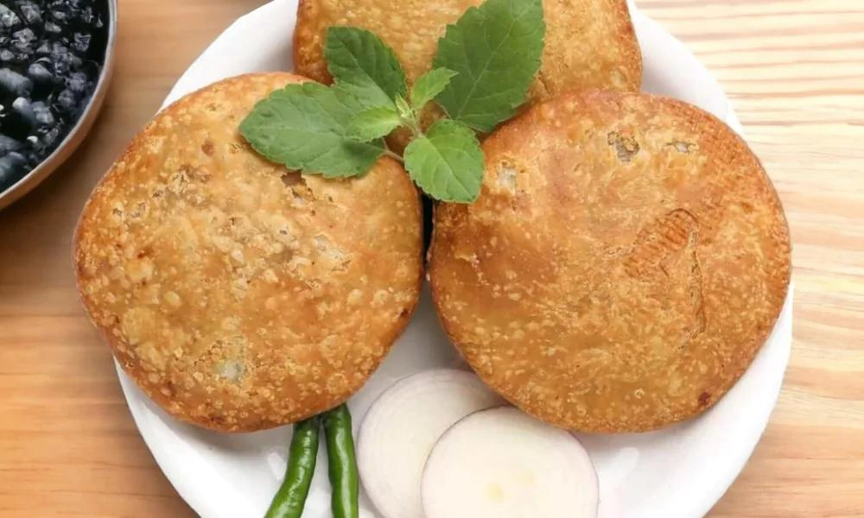
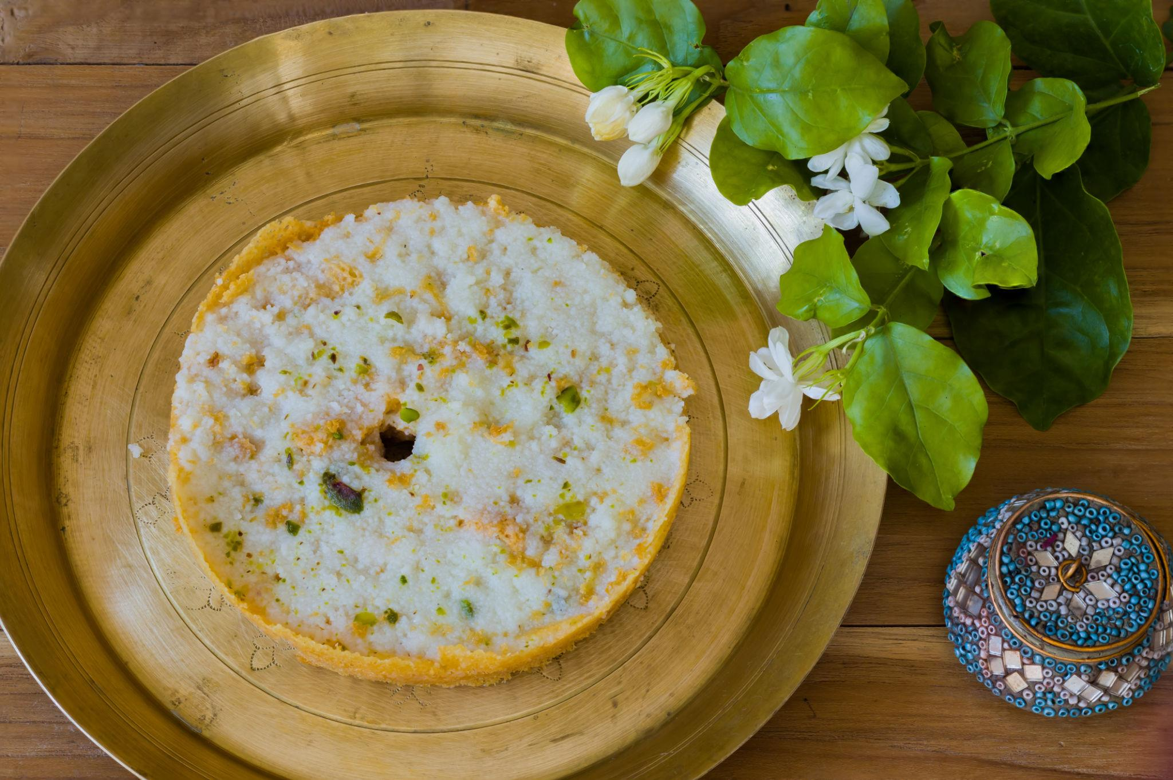

Luxury Experiences in Jaipur ✨
- Stay in heritage palace hotels
- Private royal dining experiences
- Hot air balloon rides
- Luxury cultural evenings
- Spa & wellness retreats
- Vintage car tours
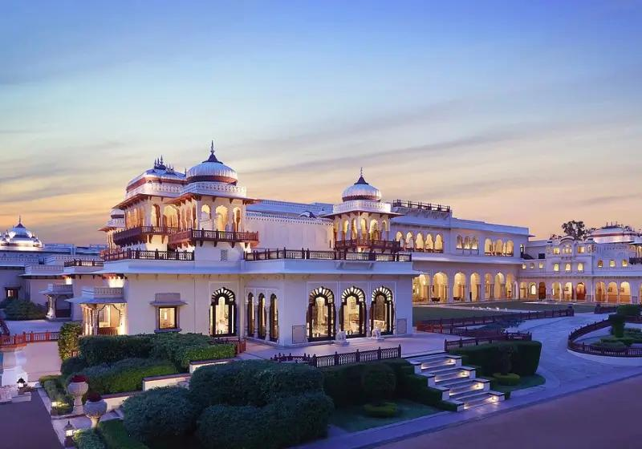
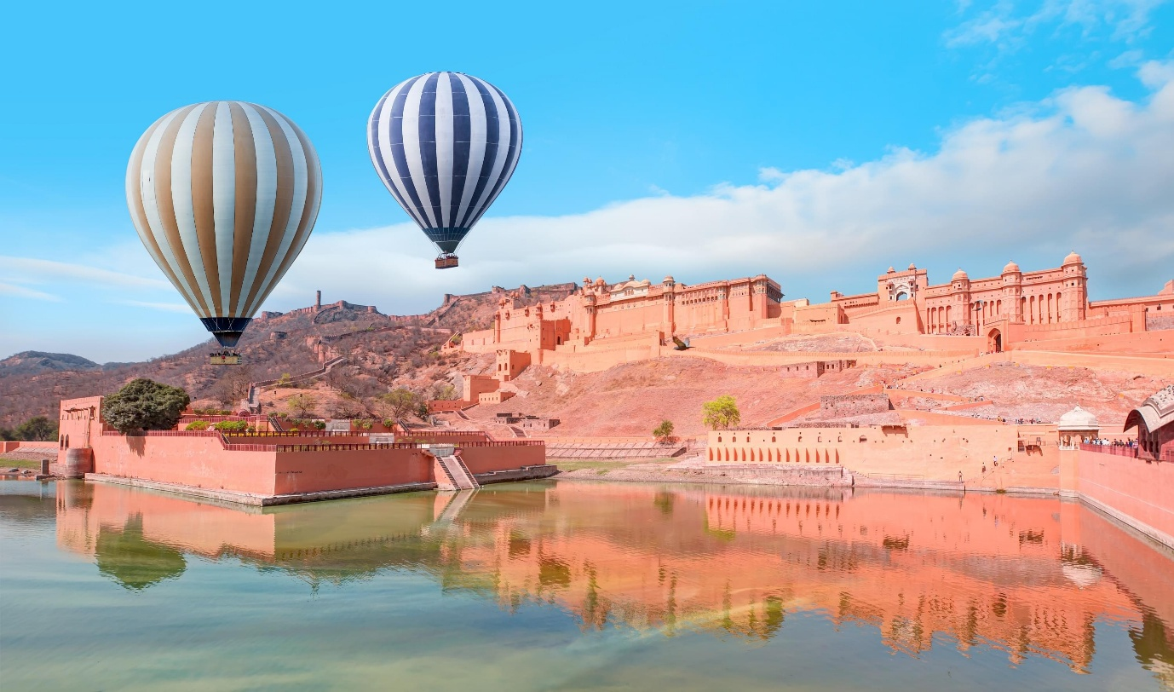
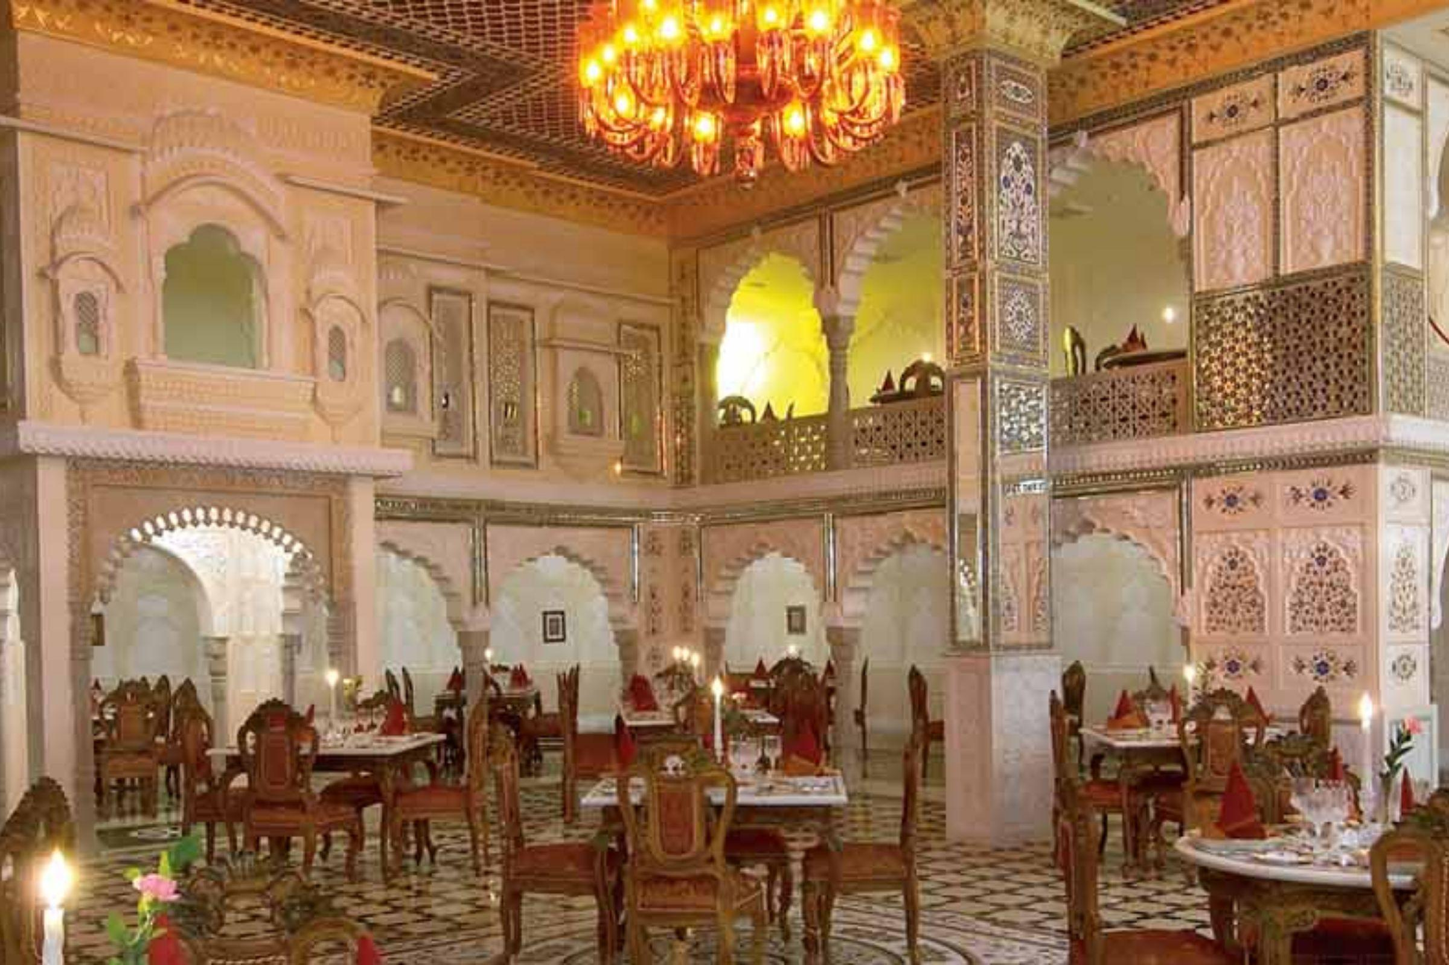
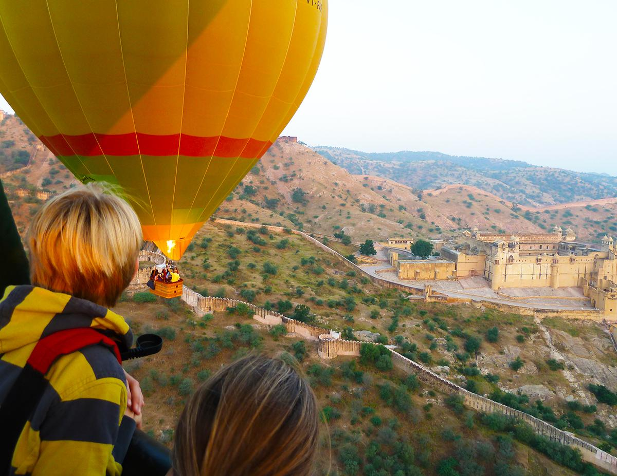
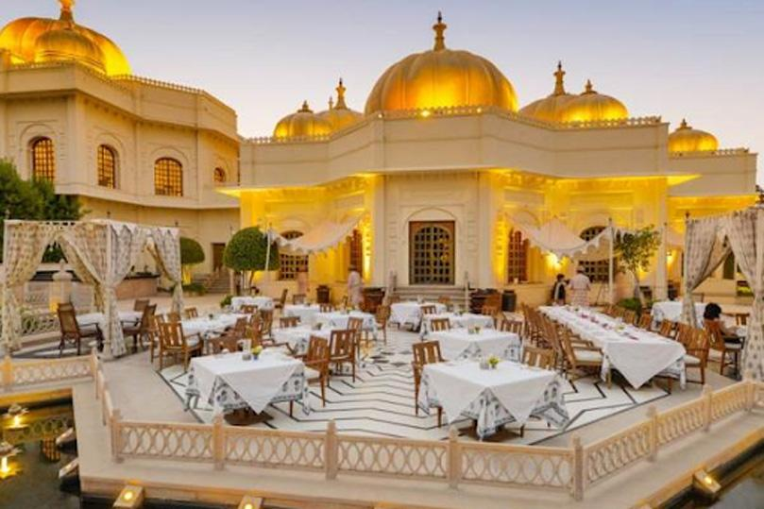
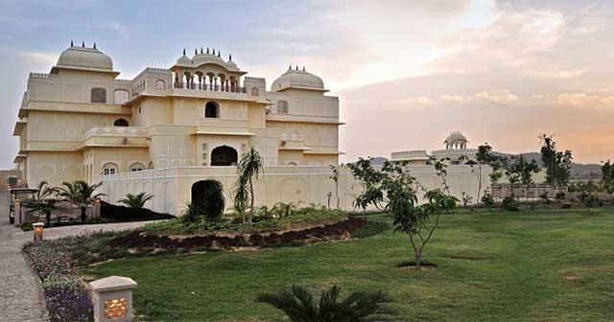

Jaipur Travel Tips
- Carry comfortable walking shoes
- Wear light cotton clothes during summer
- Bargain politely in local markets
- Visit forts early morning
- Carry sunscreen & water bottles
- Respect local traditions & heritage sites

Why Choose INTRO TRAVELS INDIA for Jaipur?
With INTRO TRAVELS INDIA, you get:
- Customized Jaipur holiday packages
- Heritage & cultural tours
- Luxury heritage hotel options
- Guided sightseeing tours
- Comfortable transport arrangements
- Family & honeymoon packages
- Shopping & food experiences
- Group departures & private tours
Jaipur is a destination where royal palaces, majestic forts, colorful culture, traditional markets, and rich history come together to create a truly unforgettable Indian travel experience. ✨🐘🏰

